HOW EXTRACT FANS WORK 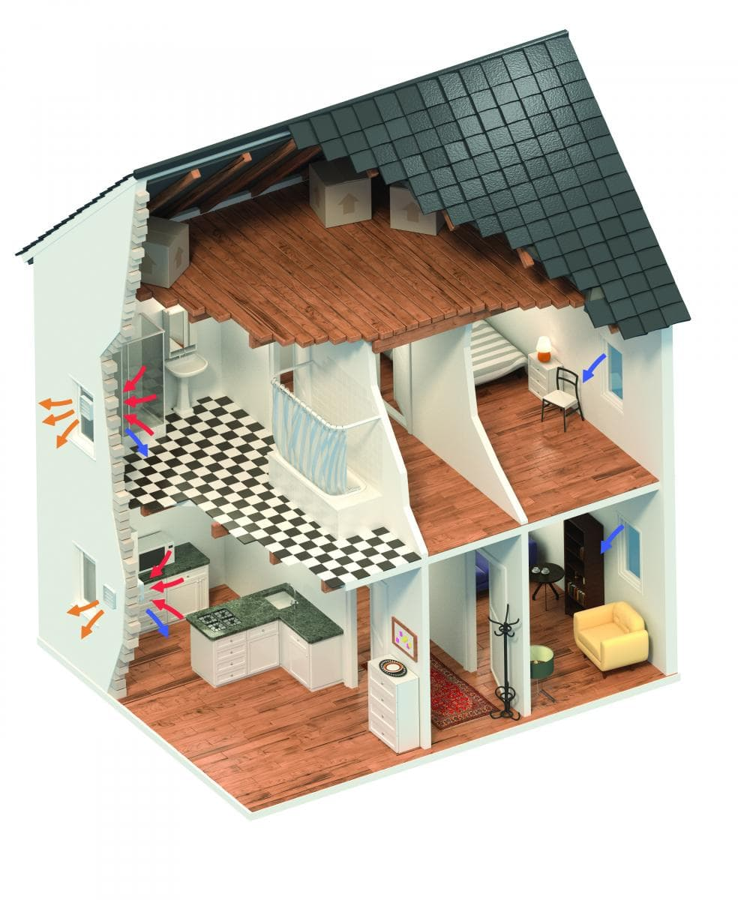
New houses are being built with better construction methods and are more airtight, which can lead to condensation dampness and poor indoor air quality if adequate ventilation is not provided.
Extract fans are fitted in a dwelling’s ‘wet rooms’ and provide rapid extraction of moisture and pollutants. An efficient extract fan will remove moisture from the air, preventing condensation and the associated problems and improving the indoor air quality.

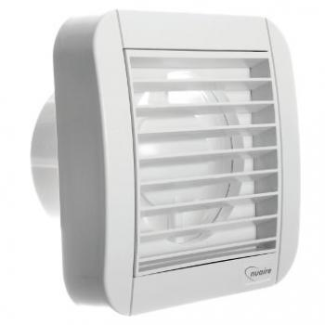
Exceptionally quiet, high performance extract fans for individual room extract, the domestic axial twin speed range provides continuous running for guaranteed ventilati

The domestic range of twin speed axial fans incorporates three models. The fans have been specifically designed to ventilate small rooms such as toilets, bathrooms and utility rooms and are ideal for wall, ceiling, window or panel installations. The units extract directly to the outside or through a short length of ducting.
Features & Benefits:
- Continuous Running - For guaranteed ventilation
- Ultra-Modern Design - Provides an unobtrusive installation and occupant acceptability
- IPx4 Splashproof - Units can be installed safely in Zones 1 & 2
- Quiet Running - Exceptionally low noise operation for occupant acceptability
- Boost Facility - For additional airflow via pull cord or remote switch
- Easy and Flexible Installation - Can be surface mounted or recessed, with window kits available
- Maintenance - Clip off cover for cleaning access
- 1 Year Warranty - For peace of mind (UK & Ireland Only)

NA100XPC & 150XPC TWIN SPEED FANS
Supplied by Nuaire, the domestic Axial Twin Speed fan is suitable for installation in a wall, panel, ceiling or window (with optional kit). The fan has three speeds, allowing a choice of one of the two lower speeds for quiet, continuous operation at installation. The user is able to boost the fan to its maximum speed as necessary. The fan is made of shockproof high quality polymer and has a maintenance- free, self-lubricating sleeve bearing motor for long life and incorporates thermal cut-out.
The fan is double- insulated, splashproof and CE marked. It is capable of operation up to 9 l/sec, at 4 Pa, 2.6 watts at low speed 1, and at 12 l/sec, 14 Pa and 4.8 watts at low speed 2. Finally, the fan complies with EN 60335-2-80, EC Low Voltage Directive LVD 2006/95/CE and EC Directive EMC2004/108 and is CE marked.

