



Welcome to your new home
This handbook has been compiled as a guide to
help you run your new home and its equipment. It is also intended to give information and some
useful tips. We welcome you to your new home, and wish you every happiness in it.

Contents

Moving into your new home - Important Information 6

Home owners 6

1) Introduction 7
1.1 Parking 8
1.2 Postal Address 8
1.3 Utility Suppliers 9
1.4 Insurance 9
1.5 Reporting Defects 10
1.6 Do's and Don'ts 11
1.7 Annual Servicing List 12

2) Energy and Ventilation, Heating and Hot Water 14
2.1 ASHP 14
2.2 Vaillant Hot Water Pump 16
2.3 Heating Programmer 17
2.4 Radiators 18
2.5 Heating Performance 18

3) Electricity 19
3.1 Electric Meter 19
3.2 Consumer Unit 19
3.3 Energy Monitoring System 19
3.4 Electrical Safety 20
3.5 Circuit Breakers 20
3.6 Lights 21

4) Ventilation 22
4.1 MVHR 22

5) Solar Panels and Batteries 23
5.1 Home Battery 24
5.2 EV Electric Car Charger 25

6) Water 26
6.1 Water Meter 26
6.2 Isolation Tap 26
6.3 Washing Machine Connections 26
6.4 Showers 26
6.5 Anti-Scald Valves 26
6.6 Dealing with Leaks 27
6.7 Tips to remember during the Winter Period 27

7) Alarms 28
7.1 Smoke and Heat Alarms 28
7.2 Your Domestic Fire Sprinkler System 28

8) Windows and Doors 30
8.1 Windows - Nordan UK 30
8.2 Doors 30
8.3 Keylite Loft Ladder 30

9) External areas 31
9.1 Shed 31
9.2 Rotary Line 31

10) Running your new home 31
10.1 Drying Out 31
10.2 Movement and Shrinkage 32
10.3 Condensation 32

11) Finishes and Materials 33
11.1 Floors (Bathroom, Kitchen and WC) 33
11.2 Other Floors 33
11.3 Walls and Ceilings 34
11.4 Ceilings 34
11.5 Fixings 34
11.6 Decoration 35
11.7 Redecorating 35
11.8 Sanitary Ware & Kitchen Units 35
11.9 Kitchen 35
11.10 Sustainable DIY 35

12) Garden Maintenance 36
12.1 Turf 36
12.2 Outside Tap 37

13) External maintenance 38
13.1 Timber cladding 38
13.2 External Render 38
13.3 Sustainable drainage systems (SuDS) 38
13.4 Easements 39
13.5 Permitted Development Rights / Car Park 39
13.6 Bird / Bat Boxes and Hedgehog Highway 39
13.7 Estate Charge 40

14) Refuse and Recycling 41

15) Driveways and Roads 41

16) Site Safety 42

17) Transport 42
17.1 Bus Service 42
17.2 Local Taxi Services 42
17.3 Local Rail Services 43

18) Local Amenities 44

19) Emergency Telephone Numbers 45

20) Links, References and Further Information 45

21) Energy labels explained 45

22) Notes 46

Moving into your new home - Important Information
No home is maintenance free and proper and timely maintenance can extend the life of many of the components and systems included in your new home.

Home owners

Please report any visual damage such as chips and scratches within seven days of completion on one list.
Within 7 days

Arrange a service for your air sourced heat pump (located in your yard) and mechanical vented heat recovery unit (located in your loft), including change of filters. This will ensure warranties remain intact. Also it would be recommended for you to service other elements as noted in section 1.7.

Every 12 months

Your Buildmark warranty covers you for putting right any damage or defects in major structural items like foundations, walls floors, and below ground drainage.

Years 3 - 10/12*

Please note your NHBC policy document for full details, and terms and conditions.

*In some cases, the cover may be shorter, should there be a lag between the point the home was legally completed and when you moved in. Please refer to your NHBC cover note for further details.
Affordable Rent (Codi Homes & Communities) customers
During your first year, please report any defects to our Customer Care Team on 0330 175 9726. These will be dealt with in a timely manner by the contractor, some defects such as shrinkage will be completed at the end of the Defect Liability Period.

At the end of the 12 months the contractor will attend the property and carry out an end of defects inspection and complete repairs on any necessary items.

Year 2 onwards - all defects or repairs need to be reported to the Codi Solutions Team on 0330 175 9726.

Introduction


Your home has been constructed by:
Hale Construction Ltd
Constructed for:
Codi Group

Codi prides itself in developing homes of the highest quality and in providing you with a first-class experience. It is built to NHBC Standards and has been inspected by NHBC and City and County of Swansea Building Control building control at key stages of construction. This guide should be read alongside NHBC’s ‘Guide to your new home’.

The building itself has been constructed using a prefabricated insulated timber frame which results in lower heating cost with multiple renewable energy add-ons and a smart energy management system. We have tried to source the materials in your home from sustainable sources such as locally grown timber from Wales, reconstituted roof slates, and wood fibre insulation. Gas is not used to heat or provide hot water, but instead relies on electricity, much of which is from renewable sources.

The guide itself has explanations of the equipment/features installed, how to use them effectively and maintenance instructions to ensure your home functions as efficiently as possible. It also gives tips on how you can live a more sustainable life resulting in savings on energy, water and household running costs.

It also gives details of your local waste collection services such as; the days of collection and what to do with bulky waste items. It gives addresses and contact numbers for your local GP, Post Office, supermarket and other local amenities.

The homes at Gwynfaen have been built using a ‘fabric first’ approach. This means we have specified certain components when building the homes and focused on reducing the home's heat loss so the home is affordable to heat. This includes:

- Maximising airtightness
- Increased levels of insulation
- Optimising solar gain through the provision of openings and shading - window positions have been carefully chosen and triple glazed windows used for further heat retention.

The homes at Gwynfaen include an airtight membrane. When customers are hanging items from the walls (e.g. TVs, shelves, pictures) they need to be aware that they should where possible screw into the battens behind the plasterboard located approx. every 600mm. If this is not possible, they should not use screws any longer than 50mm as using screws any longer will break the airtight membrane and decrease the thermal efficiency of the home.
Whilst we fit loft ladders for maintenance of equipment in the loft it is not a habitable room. If you want to convert the loft space, you MUST seek the appropriate advice and planning consent. Conversion of the space or inappropriate storage of materials without sufficient clear surround space to the MVHR Or home battery might compromise the energy efficiency of your home.

Parking
Your property has two allocated car park spaces on your own driveway or directly adjacent to your home. In some cases, there are demarcations on the pavement illustrating your space and that of your neighbour’s. Parking on the highway and swale features are to be avoided. Your parking spaces also benefit from a 7kW electric vehicle charging point which charges off your power supply.

Once the road network is complete there will be 17 dedicated visitor parking spaces located around the site, two of which will have 22kW rapid electric charging points.

Postal Address
The postal address for your new home is as follows;

All addresses have been activated with Royal Mail.

Note that when ordering goods and services some companies may not have updated their systems with the new address.

Utility Suppliers
Your property has the benefit of mains Electricity and Water.

Your meter readings will be forwarded to the service provider along with your contact details on the day of completion and a copy given to you for your records.

You will be responsible for the Electricity and Water from that date/meter reading onwards. We will take an energy meter reading at handover.

Useful Phone Numbers
Dwr Cymru Welsh Water (Water supply) Account Enquiries | 0800 052 0145
BT (fibre phoneline/internet/TV option) | 0800 800 150
Virgin (fibre phoneline/internet/TV option)* | 03454 541 111
Hyperoptic - (fibre phoneline/internet option) | 03333 321 111
Vaillant (hot water pump and air source heat pump) | 0330 100 3540

You will be set up with EON Next for electric supply when you move in. You can set up payment details and track your usage in the EON Next App, as well as choosing which available tariff is the best for you, otherwise you are free to shop around and find the final energy supplier that’s right for you.
*Please note that Virgin infrastructure and wiring has been installed on site and to your home as part of the development, however you will need to liaise with Virgin regarding availability and installation of services

Insurance
Codi do not insure you for either contents in your home or your personal possessions. It is strongly advised you arrange a comprehensive policy covering you for fire, burglary, storm, flood, and other risks as soon as you move in.

If you have bought your home through shared ownership, buildings insurance is covered by Codi Collections.

If you have bought your home your home outright, then you are responsible for purchasing buildings insurance.

Reporting Defects

If you have any repairs, you will be required to use the Clixifix Resident Portal in order to liaise with Codi’s Customer Care Team.
The portal allows you to raise defects, which will be triaged and send to Hale, where necessary. All communication regarding your request will be directly through the portal.

In addition to this Home User Guide, you will received a Clixifix Resident Portal user guide, which explains how the portal works and gives you a step-by-step guide that you need to follow in order to raise a defect.
Shortly after you move into your home, you will receive an email from Clixifix that will contain a link for you to set up your account.
It is important that you only log defects on the portal as the system is not designed for general enquiries.

Whilst clixifix is the preferred and most efficient option for reporting defects you can also report defects in your home by contacting our Customer Care Team during office hours (Monday – Thursday 9am to 5pm, Friday 9am to 4:30pm)

0330 175 9726
defects@codigroup.co.uk
Useful fixture user guides and manuals can be found on the website:

www.codicollections.co.uk/mypoblhome
Out of Hours & Emergencies:

0330 175 9726

Do's and Don'ts


DO
- Use the EON Next App to access your account and understand your energy usage to reduce bills.
- MVHR, Use the booster button in the bathroom or kitchen should you be cooking with lots of steam or showering.
- Change your heating settings on the Vaillant app should the home be too hot or cold for you.
- Change MVHR filter annually and keep minimum clear distance around unit.
- Service ASHP and cylinder annually, and keep minimum clear distance around unit.
- Change your hot water settings on the Vaillant app should you not be getting sufficient hot water.
- Keep access to technology (MVHR and battery) in / within loft so that they can be easily reached and serviced.
- When customers are hanging items from the walls (e.g. TVs, shelves, pictures) they need to be aware that they should where possible screw into the battens behind the plasterboard located approx. every 600mm. If this is not possible they should not use screws any longer than 50mm as using screws any longer will break the airtight membrane and decrease the thermal efficiency of the home.
- Register your kitchen appliances and Electric Car Charger warranties with the manufacturers within 30 days of moving in. The ASHP, MVHR and Battery warranties have already been registered by the Contractor.
PLEASE BE AWARE:
you may be charged for call outs, which are reported as emergencies but are not or to attend to problems created by willful damage.

- Use a detector before drilling or nailing.
- Use a competent electrician, should you wish to make any alterations, investigations or maintenance to electrical components. Any issues around heating and hot water should be raised with Codi Customer Care Team in the first instance.
- Complete and return all appliance warranty documents to the manufacturers as the guarantee is held directly with you, and you must arrange all service calls directly with the manufacturer.
- Use suitable precaution when using the loft ladder Take Note of Site Safety guidance in section [16]

 DON'T
- Switch off the ASHP or BEE (affordable rents only) as it runs automatically based on settings set up for you when you move in. This can be changed via the Vaillant App
- Switch off the MVHR.
- Share your code/card for your EV charger to anyone.
- Kick balls or lean anything against the ASHP unit.
- Put anything within the 350mm of MVHR
- Switch on immersion heating permanently (near boiler) unless there is a heating issue. I.e. keep switch off generally

Annual Servicing List

The below low carbon items will need annual servicing, which will need to be arranged by homeowners and shared owners.

If you are an affordable rent customer, this will be arranged by Codi’s Assets Team. The team will contact you to arrange this. Please note failure to provide access will be a breach of your contract.

MVHR
    - Life Span: 15 Years
    - Warranty: 2 years. The warranty starts from the day of delivery and includes parts and labour for the first year. The remaining period covers replacement parts only.
    - Servicing: filters are to be inspected every 6 months and replaced every 12 months (or sooner if required). Failure to do so may impair the performance and energy efficiency of this unit.
    - Replacement parts can be ordered by contacting: telephone: 02920 858 400 or Email: aftersales@nuaire.co.uk

ASHP
- Life Span: 10-15 years
- Warranty: In the first 12 months from installation, the guarantee covers your heat pump against manufacturing defects for both parts and labour . Though there is a 7 years from installation, the guarantee covers manufacturing defects for both parts and Labour
- 10 Year manufacturer guarantee if serviced annually
- Servicing: we have been provided with the below quote from Vaillant:
  - 10 year manufacturer guarantee
  - 9 Annual services
  - £2,250 (One off payment). INC VAT - 9 annual payments of £250
- Call us on: 0330 1003540 (Monday – Friday between 08:00 –17:00) or Email: aftersales-uk@vaillant-group.com

Battery
    - Life Span: 20 Years
    - Warranty: full system warranty for 10 years / 10,000 full cycles (whichever comes first).
    - Servicing: home batteries have no annual servicing requirement

Sprinkler
- Life Span: maximum of 20,000 starts per unit
- Warranty: The Grundfos warranty covers all defects within the FireSAFE originating from faulty workmanship and/or materials for a period of two years from the date of installation or thirty months from the date of despatch from the factory, whichever is the shorter. The warranty covers the replacement of any faulty parts and our labour cost to replace the faulty parts.
Servicing: annual servicing and inspection required.

Hot Water Cylinder
- Warranty: Cylinder come with a 2 year standard warranty. The shell comes with 25 year warranty.
- Servicing: annual servicing can be completed through Valliant.

EV Charger
- Life Span - no specified lifespan
- Warranty - There is a 3yr Warranty on the EV Charge Point from original date of purchase.
- The warranty will not apply to defects or service repairs resulting from the following circumstances:
Improper site preparation or maintenance.
Improper installation.
External damage to the unit.
Wi-Fi/internet/app connectivity issues, not related to the unit.
Abuse, vandalism or damage caused by accidents, misuse or negligence (including but not limited to, physical damage from being struck by a vehicle).
Damage to the unit caused by software, interfacing or other parts not supplied by EV charger.
- Servicing - recommended annually.

PV Panels
    - Life Span: 20 Years
    - Servicing: No requirement for a dedicated test, just part of the overall 5 year electrical service

Energy and Ventilation, Heating and Hot Water

ASHP

Your 7kW Vaillant AroTHERM plus heat pump is an air to water heat pump, which means it provides both the instant hot water in your home and powers your central heating. This model is highly efficient and has been endorsed by the Energy Saving Trust, great news for your carbon footprint, as well as your energy bills. With sound power as low as 54dB(A) and have been accredited with the Quiet Mark.
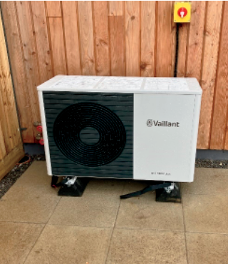
The Air Source Heat Pump is located on the patio (looks a bit like an air con unit) –
a 900mm space needs to be maintained around the pump to maintain air flow.
Air source heat pump is insulated to protect it against cold weather in winter months.

It sucks air from outside, then uses it to heat a special refrigerant liquid. As it warms up, the liquid turns into gas. This gas is then compressed to increase its temperature, which is then transferred around the home. Once the gas cools down, it becomes liquid again and gets re-used at the start of
the cycle.

It’s a type of heating that works like a fridge freezer in reverse.

The air source heat pump will work effectively at Gwynfaen because they are being installed in homes that are very energy efficient and air tight. The homes at Gwynfaen are EPC A rated.

The heat pump heats water in the system to 45 degrees - a lower temperature than traditional boilers - so the radiators that have been installed are bigger than traditional radiators - they have a larger surface area which gives the heat output you need.

With a low temperature heating system the most efficient way to operate the system is to set a consistent schedule. Your heating control is provided by the Vaillant App (refer to Vaillant for further information on how best to utilise their app).


We’ve created a handy video, which explains how the Vaillant ASHP works and how to get the most out of it. You can view it at https://pobl.co/vaillant or use the QR code to the right to view on your smart phone.

To keep your air source heat pump running efficiently and correctly, please keep the following in mind:

Check your heat pump: particularly in the autumn and winter; a build-up of leaves or snow will affect its operation.
Do not stack things against or on top of the heat pump such as a bike or fold-up garden furniture - this could restrict the airflow or damage the unit.
Keep the area around your heat pump free of clutter and mess: a 900mm space needs to be maintained around the pump to maintain air flow. The heat pump will pull heat energy from the air, and the cleaner the air flow, the more heat it will be able to absorb and use to heat your home.

Your air source heat pump is insulated to protect it against cold weather in winter months.

What is a De-Icing Cycle?

On colder days you may see steam coming from your heat pump, this is normal. It’s called the de-icing cycle. As the heat pump takes heating energy out of the air, ice can build up on the back of the heat pump. Once the ice temperature hits a certain level, the heat pump will go into the de-icing mode, heating up and clearing the ice from the back of the unit. When this takes place, you will see steam coming from the unit, and water coming from the bottom of the heat pump. The de-icing cycle should only last a few minutes.

It is recommended that a yearly service is carried out by a suitable qualified installer to maintain the product warranty.

With regular maintenance Air Source Heat pumps should last over 15years.

In the first 12 months from installation, the guarantee covers your heat pump against manufacturing defects for both parts and labour.

The ASHP has a warranty of 7 years, with an option to increase to 10 years if you take out a maintenance agreement with Vaillant at an additional cost per year, see service support document for more information.

For Further Information Call us On : 0330 1003540
Email : aftersales-uk@vaillant-group.com
Lines are open 08:00 -17:30 Mon -Fri

Please see specific Aotherm handover guide for more information.

Vaillant Hot Water Pump

Water is heated and then stored in the cylinder ready to use whenever it’s needed. Storing hot water in this way is more energy efficient and the Vaillant cylinders experience minimum heat loss after 24 hours.

The hot water cylinder does have an immersion heater for back up, this can be used to boost hot water if you ever need it. The bigger the house, the bigger the hot water cylinder.

Once a week the system will purge and run a cycle to remove any risk of Legionnaires.

Hot water temp of taps will be 40 degrees.

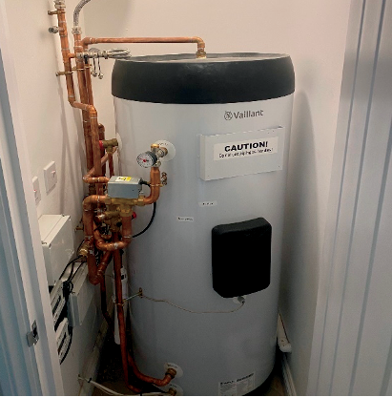
The Vaillant system runs a weekly Legionnaires prevention cycle. The unit ramps up the temperature of the water in the cylinder to kill off any bacteria build up. We set this up automatically to run every Sunday morning but you can alter this on the Senso Comfort thermostat.

The photo shows of a typical set up of a hot water cylinder at Gwynfaen. The
hot water cylinder is mostly located in the cupboard on the landing.

Heating Programmer

To program your heating you will need to download the Vaillant App, details will have been provided as part of the registration process.

Your home has a single-zone central heating system. This means you have one central heating thermostat located on the wall in the lounge. This controls the heating for the ground and first floor.

The central heating can be programmed to suit you and your lifestyle via the Vaillant App and the thermostat. Details of how to download and use the App will be provided upon moving in to make sure your home’s comfort is perfect for you.

Thermostat: Vaillant Sensonet Thermostat
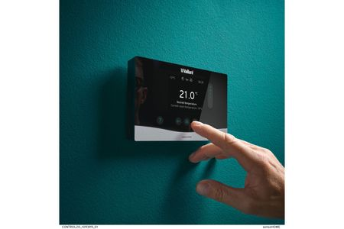

The thermostat provided will allow you to boost your heating and also turn down your set point to avoid heating coming on if you are warm enough, further details on the operation of the device are available on the Vaillant website and in the Vaillant literature provided at handover. The thermostat has 3 degree functionality. The rate of response will be slower than standard heating. Approximately an hour as opposed to 20mins for gas boilers. If you need to boost regularly, change your heating settings. Heat pumps need steady changes in temperature and minimum periods between on/off in order to work efficiently.

Radiators
You have a radiator in each room and the hall, some with Thermostatic Radiator Valve controls, this valve controls the temperature of every radiator.

All homes are on 1 zone; turning a radiator off will compromise the efficiency of the heating system.

Not all radiators will have TRVs – the number will change depending on the size of the house. Turning off radiators will cause the system to not work properly.

The heat pump heats water in the system to 45 degrees - a lower temperature than traditional boilers - so the radiators that have been installed are bigger than traditional radiators - they have a larger surface area which gives the heat output you need.
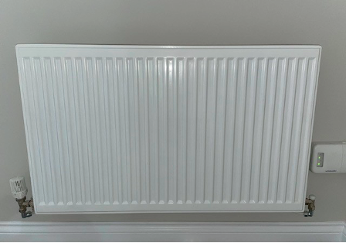
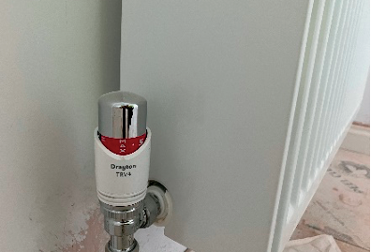

Heating Performance
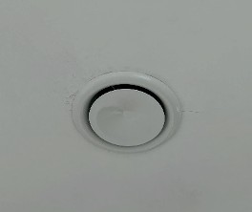
Do not drape curtains over the radiators, this will affect their performance.

Do not remove any ventilation ducts at the top of the radiator.

Do not block or seal any air vents that are installed to ensure that the ventilation system operates correctly.

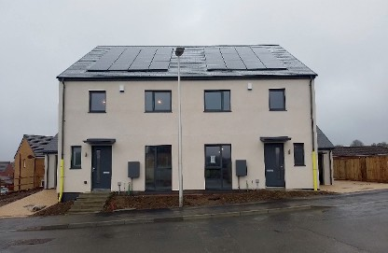
Electricity

Electric Meter
Your Electricity Meter can be found in the grey unit on the outside wall to the front of your property.

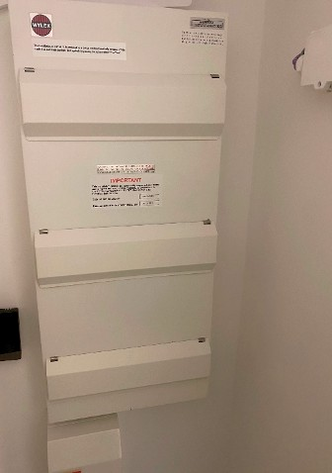

Consumer Unit
Located in electrical cupboard, there are 3 consumer boards due to the amount of electrical items in the property, each board is labeled showing the relevant supply.

The smaller consumer unit shown at the bottom of this photo is the dedicated supply to the fire sprinkler system.

Energy Monitoring System
(affordable rent homes ONLY)
The BEE (Building Energy Engine) in the electricity cupboard monitors temperature, relative humidity and levels of CO2. The Bee will monitor the energy usage and generation for the first 12 months of occupation, in fulfillment of obligations made with Welsh Government.

Codi collect information to understand how you use your home and what energy you need. This is the information that will be collected:

Indoor Environment
Your home's temperature, humidity, C02 levels

User Interactions
Scheduled heating and hot water setpoints and how you use the energy in your home to both heat your rooms and your hot water.
Your home has been installed with renewable technology like solar panels and a battery and with the BEE.

Energy
Incoming and exported energy

Renewables
Energy generation along with the renewable energy and power exported

Battery Storage
Your batteries current capacity, energy import and export status and battery control status.

All data provided via the BEE is protected under General Data Protection Act (GDPR), Data Protection Act 2018, the Privacy and Electronic Communications (EC Directive) Regulations 2003 and any other privacy laws that apply. If you would like a copy of the Data held by Codi you can request this at any time.

Please do not make changes to the BEE or its connections without first consulting Codi.

The EON Next app will allow you to manage your energy at any time.

Electrical Safety

Always ensure that appliances are fitted with the correct fuses as recommended by the manufacturer.

Always follow the manufacturer’s instructions for wiring appliances.
Never use an electrical appliance in the bathroom.
Do not attempt to repair, alter or extend electrical installations
Keep a torch handy by the control box for emergencies.

Circuit Breakers
A residual circuit breaker or RCD protects you. These breakers are easy to re-set by flicking the switch back to the on position on the consumer panel.

Circuit breakers are generally more sensitive than fuses and may well trip out even when a light bulb fails, or you are using an appliance with an electrical fault or faulty plug.
REMEMBER THAT ELECTRICITY CAN KILL:
DO NOT attempt to do any work on an electrical circuit or appliance.

Lights
Your home has been fitted with low energy fittings, energy light saving bulbs have several advantages over traditional light bulbs:

They are 5 times brighter
They use 80% less power
They will ultimately help reduce your energy bills

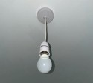
Located in lounge, bedroom & hallway:

How to change the bulb: these are a standard bayonet fitting therefore push the bulb upwards and then turn left, then remove the bulb remove to fit a new bulb, push the bulb upwards and turn right.


Located in the kitchen & bathroom:

230V IP65 5W Fire-Rated Downlight 3000K.

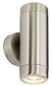
External lights:

External lights have been fitted to the front and rear of your property which are operated by a dawn to dusk sensor.

Front

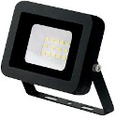

Rear of property is fitted with a PIR LED floodlight.

Back

Ventilation

MVHR

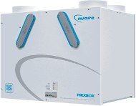
The concept of an MVHR is to bring fresh air from the outdoors into the home and at the same time extract warm moist air from rooms like bathrooms and kitchens. Both airflows pass through a heat exchanger where heat is transferred from the extracted air to the fresh filtered air which is then distributed to the living areas within the home.

Nuaire’s MVHR systems will quietly and efficiently provide the home fresh, filtered air all year round, improving the indoor air quality and reducing dust and allergen levels. Its located in the loft.

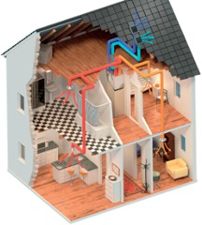
It is advised that the filters in the ventilation unit located in the grey and blue rubber slots on the unit are removed and cleaned with a vacuum hoover annually to maintain efficiency. Your MVHR unit will require annual new filter changes, these can be purchased direct from Nuaire on the below details:
Residential Sales: +44 (0) 2920 858500 - residential.enquiries@nuaire.co.uk

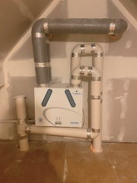
This is a typical example of the MVHR system installed at Gwynfaen, The system can keep up to 95% of heat that's normally lost through open windows, trickle vents and extractor fans, allowing you to make energy savings. It’s like recycling warm air from one part of your house to another.

Note that the system is designed to be left on at all times. Your home is extremely air tight and the MVHR system will aid ventilation and reduce the chance of condensation, Each bathroom and kitchen has a separate boost switch which directly boosts the ventilation unit output as an when the occupier feels necessary, for example following showers and when cooking.

Instructions on how to replace filters can be found in the Nuaire operations manual (basic instructions are below).


Remove the filter covers on the front panel of the unit by gripping the two circular tabs either end of the filter covers and pulling away from the unit. The filter can now be extracted by pulling the black removal loop on the front edge of the filter. Once the filters have been inspected return or replace them as necessary.

For more information on how the MVHR system in your home works, take a look at the video at https://pobl.co/mvhr or use the QR code to the right to view on your smart phone.

Solar Panels and Batteries

Your property is equipped with a solar photovoltaic array along on the roof along with a 9.53KW battery storage in the attic space which is used to power your home.

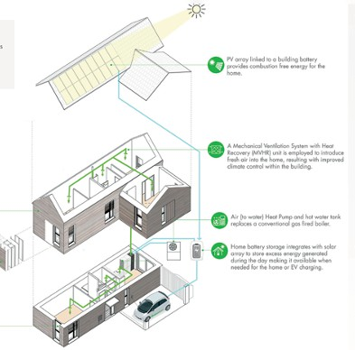
During daylight hours free electricity is generated from the sun, if not being used at that point in time the electricity being generated will be stored in the battery for use later, this means when you do need electricity you will use the stored energy in the battery before using electricity from the grid that you pay for. If you generate more energy than you use you will see a credit on your energy bill. E.g on a sunny day if you’re not home or on holiday and not using any energy, your battery will fill and the excess energy will go back to the grid and you’ll get a small payment for this (not at the rate you buy energy for – much less).

This simple diagram shows the system set up.

Please note: In order to export any excess energy your home generates back to the grid, you will need to register with your electricity supplier.

For this you will need the MCS certificate for the Solar PV, which is included in your handover pack. You will also need a letter (known as a DNO) from National Grid to confirm the ‘micro-generator’ installation. This will be sent to you by Codi when it is received (approximately 2 months after installation).

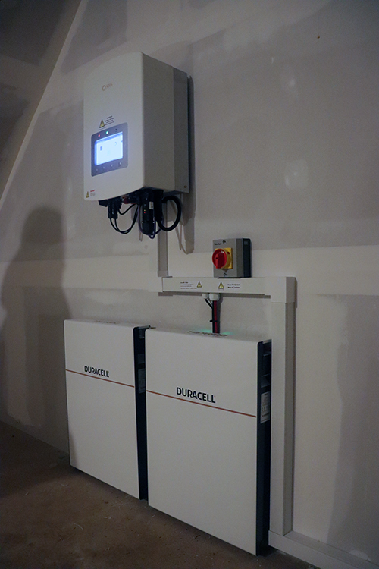
Home Battery

The Duracell Dura5 10kw battery is located in the loft in the majority of homes (apart from Lili and Lili Variation where it is in a cupboard).

We have a created a short video to explain how the battery works and how to operate it.

You can view it at https://pobl.co/duracell


Or scan the QR code below on your smart phone:

Benefits of your Battery
- Added peace of mind with our 10-year peace of mind warranty
- After 10 years the battery should still work at approx. 90% efficiency.
- A 500mm area of free space needs to maintained in front of the battery.
- If there is a power cut, and your battery is full, you still won’t have any energy because the battery needs power to operate.
- Lower your electricity bills.
- Future proof modular design.
- Our batteries are designed so that you can add to your storage capacity, future proofing you against any future changes in your household electricity demand

EV Electric Car Charger

Your home is fitted with a 7.4KW Rolec EV Evo Intelligent EV charger either attached to the side elevation of the home or on the driveway.

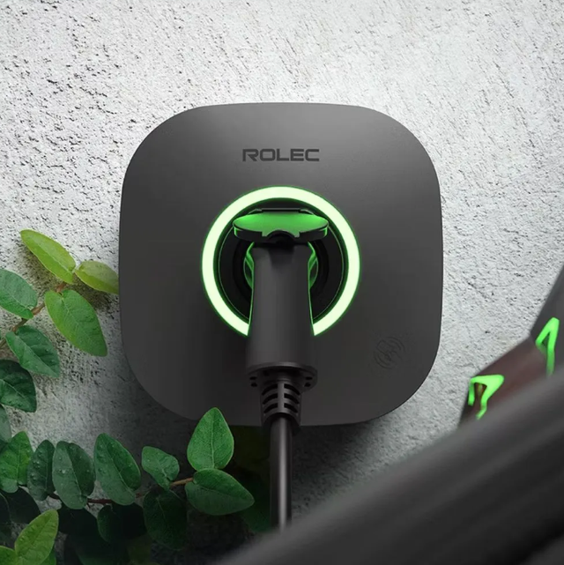
The unit is operated via the EVO Rolec app (available from the Apple Store or Google Play Store on your smart phone).

The unit has a 3 year warranty when registered.



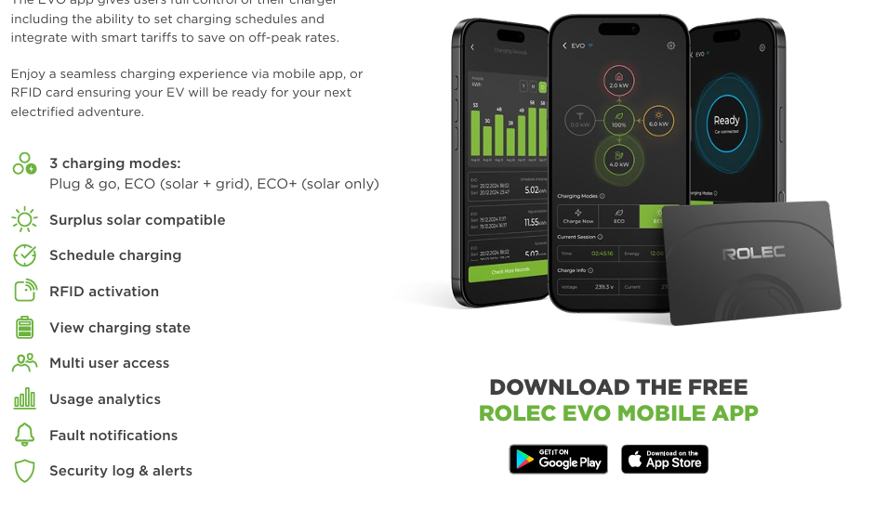

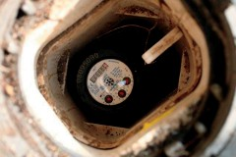
Water

Water Meter

Your Water meter is located outside on the pavement.

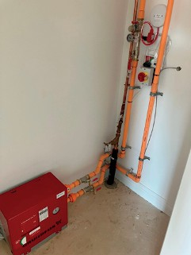
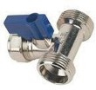
Isolation Tap
If you ever need to turn off your water, the stopcock, it is located in the cupboard underneath the stairs adjacent to the sprinkler pump. A typical example is shown in the photo.

Washing Machine Connections
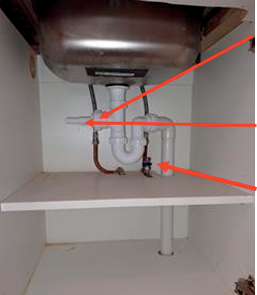
You will find the connections for a washing machine located within the kitchen sink unit. We recommend that a qualified engineer install your washing machine.

Waste connection for washing machine.
This connection needs to be cut before fitting the washing machine waste.

Showers
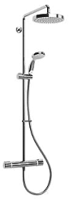
Your home has been fitted with a Mira thermostatic surface mounted electric shower which is run from the ASHP unit.

Anti-Scald Valves
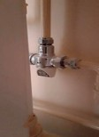
Your bath, shower and wash hand basin have all been fitted with anti-scald valves but please note that the kitchen taps do not have these fitted.

Dealing with Leaks

Minor Leaks

Minor Leaks such as a dripping tap or radiator valve can usually be dealt with without isolating the whole of the water system. This is done by using individual isolation valves.

Major Leaks

In the event of a major leak on any of the water services, turn off the stopcock (located in the cupboard underneath the stairs adjacent to the sprinkler pump). Only report to Customer Care within your defect liability period, outside of this period purchasers will need to contact a plumber. Water should be turned off and reported immediately to Codi Customer Care.

Affordable Rent customers should report leaks to 0330 175 9726.

Welsh Water Emergency Number: 0800 052 0130

Tips to remember during the Winter Period
If you intend to leave your home for more than a day or two in the winter, you should leave your heating set on a low level to avoid freezing.

If there is a risk that pipes are frozen, do not run the hot water taps as this will empty the hot water cylinder, which could cause significant damage.

Do not allow taps to drip as a dripping tap may stain the bath or basin and could result in frozen waste pipes in Winter.

It is your responsibility to drain outside taps during periods of expected freezing temperatures.

Outside taps can freeze and cause considerable flooding damage if not drained.

Alarms

Smoke and Heat Alarms
Your home has been fitted with an Aico Ei3036 smoke detector, which is located on the ceiling of the hall and landing, electric cupboard, bedrooms and attic. There are also heat sensors within your kitchen. These are all mains wired with a battery backup.

Smoke Alarm
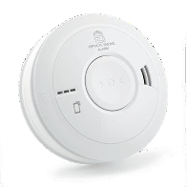
Important:
They are there for your safety - think about escape routes now! Check your detectors weekly.
The detector is sensitive to dust, and you should periodically remove any dust with the nozzle of your vacuum cleaner.
If detectors start bleeping intermittently the battery backup inside the detector needs to be changed.

Test the operation of the detector once every month by pressing the test button hard until the sounder goes off.

If you have changed the battery and the detector still fails to test properly contact Codi on: 0330 175 9726.

Your Domestic Fire Sprinkler System

Following changes with the Building Regs in Wales, all homes are fitted with a sprinkler system, you may have a pump or tank in the loft to ensure the required water pressure for the sprinkler system. There is a separate stop tap for the sprinkler system. The system is heat activated and will only activate upon intense heat in the area of the home where the heat is detected.

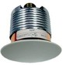
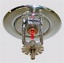
Your sprinkler system has been designed and installed to be fully compliant to BS 9251:2014 and has been certified as such. In the event of a fire the decorative circular cover plate that can be seen on the ceiling will fall away at around 60 degrees C revealing the sprinkler.

ONLY HEAT WILL AFFECT THE SPRINKLER, SMOKE WILL NOT CAUSE THE SPRINKLERS TO ACTIVATE.

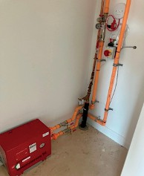
There is a control valve for the sprinklers located in the storage cupboard under the stairs. The valve is open when the red handle is in line with the pipe. To close the valve simply rotate the handle to be at right angle to the pipe.

The Fire & Rescue service strongly recommend that the valve is not closed after a Fire until they have checked the situation as fires have been known to re-ignite.

False activations of sprinkler systems are extremely rare, and the system requires very little attention.

Affordable rent homes only:
The standard recommends an annual service and inspection, so access will be needed to check your system at least once a year. The service visit will be arranged by Codi for affordable rent homes and should take no longer than 15 minutes.

Fire Sprinkler

    - The system uses no electricity.
    - Any water used in a Fire or during any testing is not chargeable.
    - If the decorative cover plate falls away when there is not a fire there is no need to be concerned as only heat will set off the sprinkler. Replacements are readily available.
    - If your system is not serviced annually your home insurance may be affected so it is important that access is made available when servicing is due.
    - If there is a Fire only the sprinkler closest to the Fire will activate.
    - In the event of a Fire the sprinklers will control or extinguish the fire.
    - In the event of a Fire leave the property and dial 999 for the Fire & Rescue Service.
    - Water from the sprinklers will be far less damaging than uncontrolled fire damage.
    - Remember – Only Heat will activate a Sprinkler, Not Smoke

Windows and Doors

Windows - Nordan UK
All windows are triple glazed. Windows with security latches will only open 100mm in operation. The restrictors need to be removed or altered for the window to be fully opened.

Cleaning and Care
- Use only warm, soapy water and a soft sponge. Never use abrasive, chemical or solvent cleaners. Keep drainage slots clear.
- Locking mechanisms should be kept clean and lightly lubricated with products such as WD40
- Hard tools must not be used to scrape glass.

Doors

The front doors are security doors.

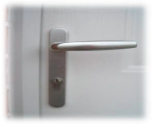
To Lock:
Push the handle up and turn the key to the left.

To dead lock:
Lift the door handle and turn the key.

To open:
Turn the key to the right and pull the handle down.

The Locking System will require occasional oiling stop the system becoming stiff.

Keylite Loft Ladder

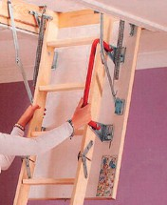
Keylite Loft Ladder has a continuous seal around the trapdoor to reduce heat loss. The loft ladder has a 30 minute fire rating and protective feet to help prevent scratching. Also comes with a 3 Year guarantee.

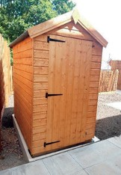
External areas
Affordable Rent Customers ONLY

Shed
Your house is provided with a lockable shed in the rear garden area.


Rotary Line
Your house is provided with a rotary dryer within the rear garden area.

Running your new home
Your new home is extremely energy efficient and is EPC A rated. It has been designed and built using quality materials reflecting all the attention to detail you would expect. Naturally, you will want to keep your home looking as good as new for many years to come and this can be achieved by following the advice given below.

Drying Out
The building materials used while your new home was under construction will contain an amount of embodied moisture. This moisture needs to disperse, and the process of evaporation will continue even after you have moved in. It is essential that you gently acclimatise your home and allow it to dry out as naturally and slowly as possible for at least 6 months after you have moved in.

Slow evaporation helps minimise shrinkage cracking and timber movement. To aid this, you should not overheat your home and aim to keep it at a reasonably even temperature always, with conservative use of the central heating system where possible. This will allow the underlying building structure to warm up and dry out gradually.

We recommend that the Central Heating Thermostat settings are maintained at a moderate setting generally no higher than 21°C.

At the same time, the evaporating moisture needs to be ventilated away to avoid problems with condensation. Please do not turn off the ventilation system as this needs running at all times due to the low airtightness of the property for if you can each day and ensuring that.

Movement and Shrinkage

As the drying out process takes place and your home is lived in and heated, the building materials shrink slightly, which may cause small cracks to appear. These are not structural defects and can be filled and covered in the normal process of periodic redecoration, some may reoccur to a reduced extent, such cracks are inevitable and at the end of the first year we will arrange an inspection of your home with you and the building contractor will be notified to rectify any issues identified during this visit.

The period of drying out depends upon how closely the guidelines on this page are followed but should be about 6 months. However, depending on the weather conditions during the build period, the length of time to dry out your home could be up to 18 months. Minor shrinkage cracks should be left for this period and then filled with a DIY product or a flexible decorator's caulk, drying and shrinkage of the joists and other timber components used in construction of your new home may result in the appearance of the following features.

The bath and/or shower tray may drop slightly and require resealing around the edges.
Screw heads may start to show in plastered finishes. Wooden door frames may move necessitating adjustment.
Floors may drop slightly leaving a gap between the skirting and the floor itself, this is not a structural problem, simply normal shrinkage.

If you plan to redecorate, we recommend that you wait until the drying process is complete. Paint that is applied to soon may crack as the moisture in the construction evaporates.

Condensation
Condensation is steam or water vapour that reverts to water upon contact with a cold surface it can sometimes cause mould to form on walls and ceilings in areas that are less well ventilated.

Once the building materials used in your home have dried out, you should experience less condensation thanks to modern standards of insulation. However, there are several normal everyday activities that produce a good deal of water vapour and can lead to condensation around your home.

The following advice will help minimise condensation:
- Air can circulate around your home if you keep internal doors and wardrobes open whenever you can (except fire doors). Closing the kitchen door, covering pans and always using your extractor fan when cooking will prevent water vapour settling elsewhere in your home.
- You should always close the bathroom door when showering or bathing and ensure the extractor fan in your bathroom are turned on.
- Keeping your MVHR ventilation system running at all times will prevent condensation build up whenever possible but if condensation does appear, simply wipe it away.
- A home that is maintained at a warm temperature is less likely to generate condensation, so do not allow your home to remain unheated for long periods of time.

Finishes and Materials

Floors (Bathroom, Kitchen and WC)

The floors are covered with vinyl sheet, which has been stuck down.

These floors may be cleaned with water and a mild detergent or a proprietary floor cleaner.

Please ensure that no hard-abrasive types of cleaners are used.

Other Floors
It is recommended that if you require a ‘fitted’ carpet that you employ a specialist carpet layer. A 15mm tolerance gap has been left under doors for carpet which should be enough for most carpets and standard underlays. Some thicker carpets and underlays may result in the doors needing planning, this is not a snag / defect and you will need to arrange this with a carpenter.
Please note that three-storey homes, planing of doors needs to adhere to strict requirements and maximum tolerances of fire doors so please seek advice from a carpenter before altering these doors.

Walls and Ceilings
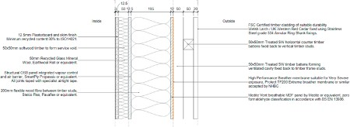
The external walls to the dwelling are of full timber frame construction with plasterboard fixed on timber battens onto the walls with a final plaster skim coat applied. The internal walls are Timber Frame built with plasterboard finish to timber studwork, the wall section is below. Fixing areas in kitchen and bathrooms and behind radiators have been reinforced with plywood aid fixing. When fixing items to external walls there are solid timbers at 600centres which you will locate with a stud finder device, be careful not to use fixings longer than 50mm as there is a VCL airtightness barrier 50mm behind the plasterboard which you should avoid penetrating.

Ceilings
The ceilings have been constructed of plasterboard fixed to timber joists and roof trusses to houses and top floor flats, lower flats a metal framing system and finished with a plaster skim.

Fixings
The homes at Gwynfaen include an airtight membrane. When customers are hanging items from the walls (e.g. TVs, shelves, pictures) they need to be aware that they should where possible screw into the battens behind the plasterboard located approx. every 600mm. If this is not possible they should not use screws any longer than 50mm as using screws any longer will break the airtight membrane and decrease the thermal efficiency of the home.

Be careful when nailing or drilling into floors, walls or ceilings to avoid contact with any electric cables or pipes, which may lie beneath the surface.

NEVER ATTEMPT TO DRILL OR NAIL A FITTING DIRECTLY ABOVE OR BELOW ANY SOCKET OUTLET OR SWITCH.

Plasterboard partitions need the correct type of fixings, not just nails. Consult your local do-it-yourself store for advice if in any doubt.

Decoration
All plaster and plasterboard have been painted with emulsion paint. All woodwork, that is skirting, architraves etc, have been painted with white satin paint.

Redecorating
Affordable Rent (Codi Homes & Communities) Customer ONLY
Following the twelve months’ defect liability period, the builder will make good only very large cracks that may form from shrinkage during that period as a rule of thumb is a pound coin fits in crack the builder will fill. Smaller fine cracks in plaster or paintwork can be expected as the building dries out and can be made good with normal decorating filler by the resident.

Sanitary Ware & Kitchen Units
Baths, basins, and sinks should be cleaned with recommended products to avoid damaging the surfaces.

Your home has thermostatic mixing valves installed which are fitted on the hot water pipe to ensure scalding does not occur, please do not tamper with these.

Do not use scouring or gritty cleaners. Bleach should not be mixed with lavatory powders nor allowed to stand in stainless steel sinks.

Do not flush unsuitable items, such as disposable nappies and wet wipes etc down the toilet.

THIS WILL LEAD TO BLOCKED DRAINS AND CHARGES WILL INCUR FOR CLEARANCE.

Kitchen
Sigma are the suppliers of your kitchen and appliances. Customers need to report issues with the kitchens to Codi Customer Care Team during the defect liability period.
Following on from this Sigma customer services may be able to help with replacement parts or queries with warranties.

Sustainable DIY
Once the twelve months is over and you can decorate the property, we would ask that you choose the materials and finishes wisely as these can have an impact on the environment.
Materials that are less environmentally damaging do not generally cost more, they perform well and are often widely available. For example, using reclaimed wood saves energy and resources, look out for timber that has been certified by the FSC and PEFC.

When choosing paints and finishes lookout for hazard warnings on the label and try to avoid these, try choosing ‘natural’ paints as they can contain less harmful substances. Also, paints contain VOC’s which can be very harmful to the environment so try choosing paints with the lowest VOC content, these are displayed on all products as standard.

DO NOT pour paint down the drain, please speak to your local authority on guidance for the disposal of this.

Garden Maintenance
The maintenance of the grass in your front and rear gardens will be your responsibility for the duration of owning your home. Alongside this, it will be your responsibility to water and maintain both your front and rear gardens i.e. watering of the plants. There will be an outside tap provided as part of your new home to assist with this.

In some cases, Sustainable drainage features (SUDs) may sit adjacent to your garden, which will be maintained by Codi as they are fundamental to site drainage. Please refer to title / conveyancing plan and SUDs guidance note for details.

Turf

    - Protect your lawn from hot weather – temperatures of up to 26°C will promote the growth but anything above 30°C will stunt growth.
    - If the temperature rises, avoid cutting the grass too short and instead leave it standing at about five centimetres, which will protect from the sun and prevent the soil from drying out.
    - The best time to water the grass is early morning or late evening before the warmth of the day. Watering in heat of day can burn the grass.
    - When watering the lawn, use 10-15 litres of water per sq. metre as a guide and be warned that over-watering can lead to mould formation.
    - Feed lawn every 8 weeks during growing season and use a winter feed from October to March to encourage stronger root growth to get through the winter
    - If water pooling on lawn which will be expected in high rainfall times, then using a garden fork push (depth of fork) into lawn move back and forth to open up hole slightly and repeat to all affected areas or whole of lawn. This should help in its drainage. Note the ground at Gwynfaen is clay type soil below the topsoil layer which is non permeable.
    - Keep flowering beds evenly moist. Water just 1-2 times per week.
    - It's better to water plants in the evening or early in the morning, when the soil is cooler, as less will evaporate than during the heat of the day.
    - Avoid watering leaves or plant heads to avoid mould formation, and water gently to avoid damage.
    - To prevent the growth of weeds, plant beds densely to minimise the space available for weeds to develop
    - The use of mulch prevents weed seeds from sprouting.
    - To remove weeds get to the roots by using a weeding trowel
    - Prior to the winter non growing months do not leave the turf grass over 100- 150mm as you will likely get dead areas of patch grass the following summer season. Always best to cut grass often in the lead up to winter months.
    - Keep grass and soil as far as possible from the render system, as splashing can cause staining and discolouration over time. Plants, trees, flowers etc., should not directly touch the rendering system as they can cause visible staining.

Outside Tap
There is an outside tap located on the external wall of the property in the garden. The stones located around the house act as natural drainage for the tap.
Remember to turn off your outside tap at the valve located within the sink unit and drain the tap during very cold weather. Flood damage caused by failure to drain the tap will not be logged as a defect.

External maintenance

Timber cladding
The cladding used on some of the homes at Gwynfaen is Welsh larch fire treated half lap cladding. The logs have come from 2 sites; Lake Vyrnwy and Elan Valley. The cladding should not be painted or stained. It has been fire-treated and has a life of approximately 30 years.

The colour of the larch will turn silvery-grey after 1-3 years.

External Render
The system that was installed on your property is based on polymer-silicate technology. As a result, the resistance of the system's top layers is incomparably higher than in organic systems (acrylic and silicone). The render is chemically bonded to the base coat, and even in the case of damage, there is no risk of delimitation. Due to enhanced PH level, the render is highly resistant to algae growth. The mineral components of the system ensure that the is no surface electrostatics - the system does not attract dirt. Thanks to vapour permeability, even if water gets under the system, it can evaporate freely, which is impossible for other systems.

Keep grass and soil as far as possible from the system, as splashing can cause staining and discolouration over time. Plants, trees, flowers etc., should not directly touch the system as they can cause visible staining. An adequately fixed trellis (please consult with our technical team) is required for climbing plants; however, some discolouration is possible due to the direct contact with plants.

Please let us know at defects@codigroup.co.uk if you notice any damage to your render/system, cracks, stains or loose fixtures and fittings.

Sustainable drainage systems (SuDS)
Sustainable drainage systems (SuDS) are drainage solutions that provide an alternative to the direct channelling of surface water through networks of pipes and sewers to nearby watercourses.

SuDS aim to reduce surface water flooding, improve water quality and enhance the amenity and biodiversity value of the environment. Some properties at Gwynfaen have SuDS features within their properties, for example a rainwater garden in front of the home or permeable paving on the driveway. Codi will maintain the swales and a large attenuation pond at the bottom of the site. The rainwater gardens will be maintained on the plots boundaries during the establishment period of 2 years following completion.

The attenuation basin acts as an overflow for excess water. If you have children or children visit you at Gwynfaen please be mindful of this open water feature. Please refer to SUDs guidance note for further details

Easements
A drainage easement states that access to part of the property is given to a third party for the purpose of maintaining drainage.

A drainage easement can include a drain which feeds into a drainage system or in the case of rain gardens, water should be allowed to drain into the area. What this essentially means is that purchasers cannot build on the areas of easements and should not change anything within the easement where a rain garden has been installed.

Permitted Development Rights / Car Park
Permitted development rights are removed in so far as they relate to the parking of cars (no conversion of garages and car ports will be allowed) and in relation to hard standings for vehicle parking.

Car parking spaces shall be permanently retained and used only for the parking of vehicles. This is to ensure adequate parking provision is provided and retained for each home and to ensure that the parking spaces are not inhibited by permitted development.

No hardstanding's shall be constructed/ provided forward of the principal elevation of the building line without the express permission of the Local Planning Authority. This is in the interests of visual amenity to ensure landscaping is retained and ensure front gardens are not dominated by vehicle parking.

Bird / Bat Boxes and Hedgehog Highway
Some homes have bird and bat boxes attached to them. Residents should not remove these. Rear garden fences may have hedgehog holes in fences to ensure the free movement of hedgehogs between gardens.

Estate Charge
£350 p.a. - See Estate Charge Booklet for more info.
For affordable rent customers this will be collected via your homes service charge

Refuse and Recycling
Email: direct@swansea.gov.uk or call 01792 636000 to find out when your bins are collected and what colour bag it is.

For information on collection days, which colour bags etc and where to collect bins and bags from please visit the below site. Note Swansea council do not use wheelie bins like other authorities but do provide food bins and plastic sacks etc. https://www.swansea.gov.uk/recycling?lang=en

Location of local Recycling Centre:

Garngoch Recycling Centre Phoenix Way
Garngoch Gorseinon SA4 9WF

Driveways and Roads
Final surfacing to driveways and roads is usually carried out in phases and may not be completed at the time you move in. This helps to avoid damage to the surface caused by heavy machinery.

All roads and sustainable drainage (SUDs) are maintained by Codi, save for Heol y Creyr Bach Road and Gower View Road, which are adopted and maintained by the Council.

Where dropped kerbs are present, a temporary infill strip will allow safe access/egress. These will be removed when the final surfacing is applied, but care should be taken on all temporary surfaces, in all weather conditions, until final surfacing is completed.

Site Safety
Construction work may well be ongoing when you move into your new home, and a certain amount of dust and noise is inevitable. We will, of course, make every effort to keep this to a minimum.

Please do not enter, or allow children to enter, construction areas.

Please be aware of construction traffic and take care when walking or driving. Conditions and traffic management systems can and do change. Please take note of any signage for pedestrians and vehicles, as this is there for your safety.

Also, please be mindful around the site attenuation pond at the bottom of the site, particularly with children and pets.

Transport

Bus Service
First Cymru operate the local bus serivce. Timetables: www.firstbus.co.uk

The nearest bus stop is located on Gower Veiw road. This stop is a north and southbound bus stop.

Local Taxi Services

Travelling by taxi or private hire car around the county borough should be convenient, comfortable, and safe. That’s why you should only use council licensed taxis.

Hackney cabs are black and white or are London taxi style cabs. They display a taxi roof sign and have a licence plate attached to the rear of the vehicle. Only hackney cabs can be hailed from the roadside.

Private hire taxis cannot be hailed at the roadside and must be pre-booked. There is no light on the roof and a yellow licence plate is displayed at the rear of the vehicle.

Taxi Contact Details:
Phoenix cabs - (01792) 896669
Swallow travel - (01792) 898888

Local Rail Services
The nearest railway station to the site is Gowerton, located approximately 4.5km to the south east of the development.

Gowerton Railway Station is served by Transport for Wales and provides regular half hourly – hourly services to destinations across the South Wales Mainline such as Carmarthen, Haverfordwest and Fishguard to the west and Swansea, Neath, Port Talbot, Bridgend, Cardiff central and Newport. Direct services also run to and from Manchester Piccadilly.

Gowerton station Station Road Gowerton

Currently Managed by: Transport for Wales. A regular service is in operation.

Facilities
There is a step free access, ticket machine and departure screens.

Car Parking
There are Limited Free parking spaces at this station with accessible spaces (Mon- Sun).

Assistance
Assistance is available for customers with disabilities or those who may have difficulty in joining or leaving the train. National Rail request that customers requiring assistance call 03333 211 202.

Transport for Wales Customer Relations
St. Mary’s House, 47 Penarth Road, Cardiff CF10 5DJ Tel: 0845 60 61 660 Email: customer.relations@tfwrail.wales
www.tfwrail.wales

Railway Contact Details
For more information about rail services, visit the National Rail Enquiry Service (www.nationalrail.co.uk) website or telephone 08457 48 49 50.

Local Amenities
The development is well located in terms of local amenities with a post office and convenience store located approximately 350m from the southern boundary of the site. The District Centre of Gorseinon is also within 1.5km of the site, providing a number of amenities such as healthcare facilities, grocery stores, superstores, a library and various schools.

In case of an emergency please dial 999

Location of A&E and local minor injuries clinic:
Morriston Hospital
Heoil Maes Eglwys
Morriston Swansea
SA6 6NL
01792 702222

Location of local Police station: Gorseinon Police Station
Pontardulias Road
Gorseinon SA4 4FF
(01792) 222020
Non-Emergency Number: 101

Location of local Fire station:
Mid & West Wales Fire & Rescue Service Morriston Fire Station
Morriston Road
Swansea
SA6 6JA
0370 6060699

Location of local Doctors:
Princess Street surgery
Princess street
Gorseinon Swansea
(01792) 895681

Location of local Optician:
Gorseinon Eye centre
71 High Street Gorseinon
SA4 4BP
(01792) 892906

Location of local Dentist: Gorseinon Dental Practice
40 High Street
Gorseinon SA4 4BT
(01792) 891666

Location of local Pharmacy:
Lloyds Pharmacy
High street Gorseinon
SA4 5HT
(01792) 898810

Community Hub
In the heart of the site, Codi will be developing a community hub / café. We will keep you posted as plans for the space take shape.

Emergency Telephone Numbers
Codi Out of Hours Number - 0330 175 9726
Water Emergency Number - 0800 052 0130
Electricity Emergency Number - 0800 052 0400 (24 hours)

Links, References and Further Information

Please see below link on how to run the home efficiently and in the best environmentally sound way:

The Energy Saving Trust good practice guidance. www.energysavingtrust.org.uk

When buying white goods please see the link below to purchase the most efficient model that is low energy / low water. www.greenconsumerguide.com/whitegoods.php

This Home User Guide can also be obtained in alternative formats, including foreign languages, Braille, large print, or audio CD.

These can be obtained by contacting your housing officer.

Upon completion of defects liability period, it becomes your responsibility to maintain the property (homes for sale). To be clear you will be still covered for a structural warranty with NHBC, however, for assistance with heating systems and renewable technology, it is important that future repairs and maintenance are undertaken by a suitably qualified tradesperson. Heatforce is one such contractor (info@heatforce.co.uk / 08452 600321 / www.heatforce.co.uk), but it is your responsibility to make your own enquiries to ensure whomever you use is suitably qualified for the job.

Energy labels explained
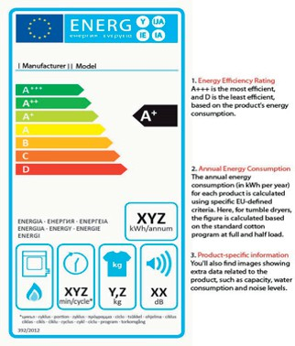
EU energy labels have become a common sight in home appliance showrooms - they are found on a selection of white goods and other products and are designed to help customers see how energy efficient a model is before they buy.

Notes

____________________________________________________________________________________________________________________________________________________________________________________________________________________________________
________________________________________________________________________________________________________________________________________________________
____________________________________________________________________________
________________________________________________________________________________________________________________________________________________________________________________________________________________________________________________________________________________________________________________
________________________________________________________________________________________________________________________________________________________
____________________________________________________________________________
________________________________________________________________________________________________________________________________________________________________________________________________________________________________________________________________________________________________________________
________________________________________________________________________________________________________________________________________________________
____________________________________________________________________________
____________________________________________________________________________________________________________________________________________________________________________________________________________________________________
____________________________________________________________________________
________________________________________________________________________________________________________________________________________________________
____________________________________________________________________________
________________________________________________________________________________________________________________________________________________________________________________________________________________________________________________________________________________________________________________
________________________________________________________________________________________________________________________________________________________
____________________________________________________________________________
________________________________________________________________________________________________________________________________________________________________________________________________________________________________________________________________________________________________________________
________________________________________________________________________________________________________________________________________________________
____________________________________________________________________________
________________________________________________________________________________________________________________________________________________________________________________________________________________________________________________________________________________________________________________
________________________________________________________________________________________________________________________________________________________



www.codigroup.co.uk
@wearecodigroup

Exchange House, The Old Post Office, High Street, Newport, NP20 1AA

