Solis Datalogger Connection & SolisCloud Site Creation

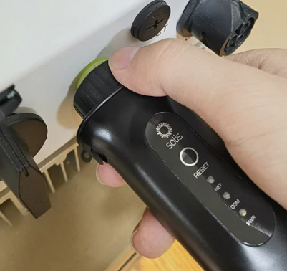
Step 1. Connect ethernet cable from the bottom of the LAN datalogger dongle (found underneath inverter in COM port) into Xero unit for internet connection.
Step 2. Download the SolisCloud mobile app.
Step 3. Open the SolisCloud app, you will be prompted with a sign in page. Click ‘Register’ to register an account. Select ‘Owner’. Insert your email address, press the orange button to send the code and complete the verification captcha. A verification code will now be sent to this email, insert the verification code on the app. Read privacy policy if you wish, then tick the box and click next.
Step 4. Create a ‘Username’ and ‘Password’ and then confirm the password. Select the ‘Time Zone’ (Europe/Dublin). Now go to the next page. You will be presented with your main home screen which will display ‘No Data’, now we are ready to add your system.
Step 5. Select ‘Add Plant’.
Step 6. This page will now allow you to add your system:
- First, insert ‘Plant Name’ (Home Address).
- Then, under ‘Plant Type’ select ‘Residential Plant’.
- For ‘Capacity(kWp)’ this can be found on your MCS certificate next to ‘Total Installed Capacity (kW)’. For example, you would write 3.40 if your Total Installed Capacity is 3.40kWp. (Another way to determine your properties Capacity is by counting how many panels are on your roof, multiplying by 340, and then dividing this number by 1000).
- Next, for ‘Region’ select your region.
- For ‘Detailed Address’, insert your full home address.
- For ‘Time Zone’, select ‘(UTC+00.00) Europe/Dublin’ again.
- Select ‘Next’ to go to the ‘Tariff Management’ page.
- For ‘Tariff Type’ leave this as ‘Fixed Tariff’.
- For ‘Tariff(GBP/kWh)’, just enter 0. Feed In Tariffs are obsolete now in the UK.
- Select ‘Next’ to go to the ‘Link Account’ page.
- If you wish to add somebody else to the plant, you can now add a guest account and insert their email address. This will send a link to the email you provide with access to the site. (If it is only going to be viewed by yourself you can skip then step).
- Select ‘Next’ for ‘More Info’ page.
- For ‘Installer’s Email’, insert admin@ice-power.co.uk.
- For ‘Installer’s Phone’, you can leave this blank.
- ***IMPORTANT*** For ‘Grid Connection Type’, make sure to select ‘Surplus Export’. This will ensure your property is powered by the solar and any excess will then go back to the grid.
- For ‘Grid Connection Time’, put todays date.
- For ‘Plant Contact’, put your mobile phone number in.
- For ‘Access Platform Time’, select todays date.
- Click ‘Create Plant’.
- You should now be prompted with a message reading ‘No datalogger was added, please add a datalogger’, click ‘Add’. If you are not prompted with this message, click the three dots in the top right corner and select ‘Add Device’.
- Your camera on your phone will now activate and it may ask for permission to allow SolisCloud to access the camera, select ‘Allow’.
- Locate the barcode on your datalogger (found underneath inverter in COM port) and scan using the barcode scanner. Alternatively, you can select ‘Manual Input’ at the bottom of the screen and enter the serial number shown on the barcode.
- Your datalogger should now be connected to your ethernet connection. If a prompt does come up after scanning ensure that ethernet connection is selected.
- After a few minutes, you should see a green/blue LED on the datalogger which indicates that the system is communicating.
- You can now refresh SolisCloud and your system should start showing data after up to 10+ minutes as it begins storing data to the system.

