

1 Lockwood Grove,
Sketty,
Swansea. SA2 8BW

HOME USER GUIDE



Contents
Contents
1.0 Welcome 3
Section 1: About Your Home 4
1.0 Your Home 4
2.0 Postal Address 4
3.0 Insurance 4
4.0 Snags & Defects 4
5.0 Emergency Repairs 5
6.0 General Enquiries 5
7.0 Service Suppliers 6
8.0 Valve Positions 7
9.0 Water 7
10.0 Heating and Hot Water 8
11.0 Other Services within your home 9
12.0 Parking Bays / Drives 12
Section 2: Running Your Home 12
13.0 Heating and Hot Water 12
14.0 Ventilation 13
15.0 Electricity 14
16.0 Meter Location 14
17.0 Using Your Energy Wisely 15
18.0 Be Water Wise-Tips to Reduce the Use of Water 17
19.0 Lawn Maintenance 18
20.0 Other Considerations 19
Section 3: Local Amenities 21
21.0 Recycling Arrangements 21
22.0 Hospitals, Schools, and Other Services 21
23.0 Local Places of Interest 23
Section 4: Sustainable Stewardship 24
24.0 Home Composting 24
25.0 Sustainability—the Whole Life Approach 25
Section 5: Useful Contacts 26

1.0 Welcome

Welcome to your new home constructed by Morganstone.

We at Morganstone realise that sometimes moving to a new home and area can be a stressful time. We have prepared this Home User Guide (HUG) to help you become familiar with your new home and local area quickly and easily. It contains information including:
- How to look after your new home.
- How to report certain types of problems.
- Initial gas, electricity and water supply information details.
- Advice on safety and security.
- Useful information on local amenities and services.

We have also included technical help and practical tips on energy saving and recycling. When you move into your new home you will be given various leaflets supplied by the manufacturers and installers of the equipment in your home. Please keep all this information in a safe place, together with this handbook so that you can refer to it in the future.

We have taken great care whilst building your home having undertaken a comprehensive suite of checks for safety, quality and environment throughout the construction process.

Your Home User Guide also informs you on many ways you can continue to help the environment, whilst saving money at the same time.

We hope you enjoy your new home and we wish you every happiness in the future.



Section 1: About Your Home

1.0 Your Home
Your home has been designed to be energy efficient and environmentally responsible, helping to regulate fuel bills and provide a comfortable, controllable living environment.

This has been achieved through:
- A regulated and tested construction method which minimises heat escape.
- Traditional construction built in line with building regulations and highly insulated.
- Responsibly sourced construction materials with proven “chain of custody” illustrating the origin of the material.

2.0 Postal Address
The postal address for your new home is as follows;
1 Lockwood Grove
Sketty
Swansea
SA2 8BW

All addresses have been activated with Royal Mail.

Note that when ordering goods and services some companies may not have updated their systems with the new address.

3.0 Insurance
Pobl do not insure you for either contents in your home or your personal possessions. It is strongly advised that you arrange a comprehensive policy covering you for fire, burglary, storm, flood, and other risks as soon as you move in.

If you have bought your home through shared ownership, buildings insurance is covered by Pobl Living.

If you have bought your home outright, then you are responsible for purchasing buildings insurance.

4.0 Snags & Defects
Within 7 days: As you start to live in your new home you may find additional snags; small cosmetic items – something that is damaged in some way or something that isn’t fitted properly, for example. It is really important that you let us know within 7 days if you find any additional snags, we cannot accept any snags after this 7-day period.

If we haven’t heard from you within 7 days, we will assume you don’t have anything to report and we will forward your handover certificate to the New Build After Care Team for their records.

Please report any snags to thewillows@poblliving.co.uk within 7 days.

If you need to report a defect in your home within the first 2 years please email newbuild-aftercarewest@poblgroup.co.uk.

Every 12 months: Arrange a service for your boiler and sprinkler system. This will ensure warranties remain intact.

Years 3-10/12*: Your Buildmark warranty covers you for putting right any damage or defects in major structural items like foundations, walls floors, and below ground drainage. Please note your NHBC policy document for full details, and terms and conditions.

*In some cases, the cover may be shorter, should there be a lag between the point the home was legally completed and when you moved in. Please refer to your NHBC cover note for further details.

5.0 Emergency Repairs
You may need an emergency repair outside office hours (evenings and weekend).
We operate a 24-hour emergency repair service which you can contact by calling:

Out of Hours: 0330 175 9726

- Give your name address and explain that you are the homeowner.
- Explain the problem clearly and in as much detail as possible.
- On taking your call the telephonist will forward to the appropriate contractor.

6.0 General Enquiries
If you have any general enquiries regarding your home. Please contact the Pobl Solutions Team who are available 9am – 5pm Monday to Thursday and 9am-4.30pm Friday.

- During Office hours: 0330 175 9726
- Newbuild-aftercarewest@poblgroup.co.uk

7.0 Service Suppliers
Your property has the benefit of mains Electricity, Gas and Water.

Your meter readings will be forwarded to the service provider along with your contact details on the day of completion and a copy given to you for your records.

You will be responsible for the Electricity, Gas and Water from that date/meter reading onwards. Your current suppliers are British Gas for Electricity and Gas and Welsh Water.

Make sure you familiarise yourself with the location of various valves and switches, this will allow you to turn off the Water, Gas or Electricity in an emergency and help prevent further damage (refer to section 8 of this Guide).

In an Emergency, know what to do and who to call.
Please be aware: you may be charged for call outs, which are reported as emergencies but are not, or those that are caused by willful damage or faulty appliances.

Electricity provider – Emergency Information
British Gas
Tel: 105

In the event of an electrical emergency or power outage please call 105 from your mobile or landline and the telephone service will automatically direct you to the network distributor's emergency number for your area.105 is a free service, available from most landlines and mobile phones in England, Scotland and Wales.

Gas Leak – 24 Hours
British Gas
Tel: 0800 111 999
If you are a mains gas consumer and you suspect CO poisoning, you should call the National Gas Emergency Service on 0800 111 999
Water Emergencies
Dŵr Cymru / Welsh Water
Telephone: 0800 052 0130
If you have an emergency, please do not wait.
Sewer Flooding & Sewerage Emergencies
Welsh Water
Telephone: 0800 085 3968
If you have an emergency please do not wait.

8.0 Valve Positions
Below is a summary of the valve positions of your new home:
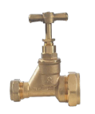 | Water  The stop tap is located in the storage cupboard underneath the stairs.
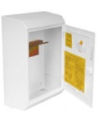 | Gas & Electric  Meter boxes are situated in the following location:  Front/side elevation of the property.
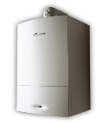 | Boiler  The boiler is situated in the following location:  Kitchen
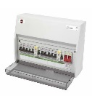 | Electric consumer units  Located in the storage cupboard underneath the stairs.

9.0 Water
Stop tap location
Your water supply can be turned off by using your stop tap which can be located in the storage cupboard underneath the stairs.

Washing machine connection
You will find your washing machine connections located under the kitchen sink unit.

Dealing with leaks
Minor leaks such as a dripping tap or radiator valve can usually be dealt with without isolating the whole of the water system.

In the event of a major leak on any of the water services, the stopcock should be turned off.

During the Winter Period please remember that:

If you leave your house for more than a day or two you should leave your heating set constantly on low level to avoid freezing.

If there is a risk that pipes are frozen DO NOT run hot water taps as this could cause the pipes to burst.

DO NOT allow taps to drip as a dripping tap may stain the bath or basin and could result in frozen waste pipes.
Remember to turn off your outside tap at the valve located within the sink unit during very cold weather.

10.0 Heating and Hot Water
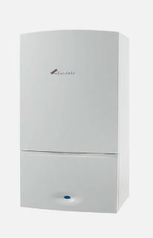
Model: Logic Combi ESP1 35
Other features of the boiler are:
- Compact and stylish cupboard fit design
- Fully modulating operation to low outputs
- Simple-to-use controls
- Built-in frost protection
- Choice of optional timers and room thermostats
The boiler is registered with Ideal Heating

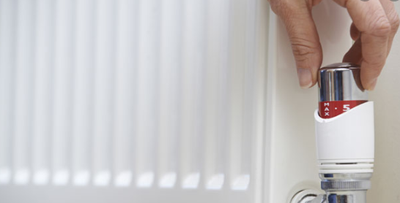
The warranty is with:
Ideal Heating
National Avenue,
Kingston Upon Hull,
HU5 4JB
To Register phone: 01482 498660

Please see the Boiler User Manual for the following:
- Using your appliance
- Heating/Hot Water Temperature
- Fill & Pressurise
- Frost Protection
- Condensate Drainage
Your boiler provides a high level of comfort whilst keeping energy consumption and the effects on the environment as low as possible.

You should have your boiler serviced every 12 months as
failure to do so could invalidate your guarantee.

11.0 Other Services within your home
Telephone
Your home is provided with a British Telecom terminal which is located in the living room.

You should contact your selected service supplier in order to become a subscriber. YOU are responsible for connection charges.

TV Aerial
Your TV Ariel Socket can be located in the living room and one in the master bedroom. The aerial cable is situated in the attic.

Satellite TV
Your property has been fitted with sockets in the living room.
You will need to contact your chosen provider regarding installation and service.

Broadband
There is a “Fibre” terminal located under the stairs.
You will need to contact your chosen provider regarding installation and service.

Smoke detectors
Your home has been fitted with smoke detectors, which are located on the ceilings in the hall and landing area and heat detectors, which are located in the kitchen. They are mains wired with a battery backup.
The smoke detector is sensitive to dust and you should periodically remove any dust with the nozzle of your vacuum cleaner.
If the detector starts bleeping intermittently the battery back up inside the detector needs to be changed.
TEST your smoke detector once every month by pressing the test button hard until the sounder goes off.

Carbon Monoxide Detectors
Your home has been fitted with a carbon monoxide detector. This is located in the kitchen area.

Fire Sprinkler

False activations of sprinkler systems are extremely rare, and the system requires very little attention.

An annual service and inspection are needed on your sprinkler system, this will need to be arranged by the homeowner.

Please Note:

- The control valve for the sprinkler system is located in the loft space.

- Any water used in a Fire or during any testing is not chargeable

- If the decorative cover plate falls away when there is not a fire there is no need to be concerned as only heat will set off the sprinkler. Replacements are readily available

- If your system is not serviced annually your home insurance may be affected so it is important that you arrange an annual service.

- If there is a Fire only the sprinkler closest to the Fire will activate.

- In the event of a Fire the sprinklers will control or extinguish the fire

- In the event of a Fire leave the property and dial 999 for the Fire & Rescue Service

- Water from the sprinklers will be far less damaging than uncontrolled fire damage

- Remember – Only Heat will activate a Sprinkler, Not Smoke

- The sprinklers automatically carry out a weekly legionnaires test, when this test is carried out you may hear some vibration noise.

DO’S:
- Do make sure you know the location of the control valve and ensure occupants are aware of its location.

- Do make certain the control valve is always open.

DONT’S:
- Do not paint the sprinkler cover plates.

- Do not hang anything such as decorations, plant holdings or anything else on the sprinkler heads.

- Do not manually turn off or disconnect the fire sprinkler system on your own accord.

- Do not obstruct or cover the fire sprinklers.

- Do not use wallpaper steamers near sprinkler heads.

- Do not interfere with any of the sprinkler components.

In the event of a fire, stay calm and leave the building immediately. Call the fire brigade from outside the building.

Sprinkler FAQ’S

Will sprinklers leak?
Sprinklers and their piping are pressure tested at two or three time higher than your plumbing system, even though they use the same standing pressure as your plumbing. Therefore, the chance of a leaking sprinkler is practically nil. Like your plumbing pipes, sprinkler pipes are not exposed to cold areas through use of lagging. Thus, preventing the pipe from freezing and bursting in colder periods of the year.

If a fire starts will all the sprinklers activate?
In the event of a fire, typically, only the sprinkler closest to the fire will activate, spraying water directly over the fire. The water from the sprinkler head cools the hot fires gases, so in nearly all cases there is not enough heat to activate the next nearest sprinkler. Thus, leaving the rest of the house dry and secure.

Will sprinklers activate anytime a smoke alarm is set off?
Each individual sprinkler is designed and calibrated to activate when it senses a significant heat change. They do not operate in response to smoke, burnt toast, cooking vapors, steam, or an activating smoke alarm.

Won’t the water create more damage than the fire?
Home fire sprinklers can significantly reduce property loss and damage in the event of a fire. The sprinkler will quickly control the heat and smoke from the fire, limiting damage to other areas of the house, giving occupants valuable time to vacate the building safely. Any resulting water damage from the sprinkler will be much less severe than the damage caused by water from fire-fighting hose lines. Fire departments use up to eight-and-a-half times more water.

Do I have to do anything in the event of a fire?
Just get yourself and anyone else out of the house! Fire sprinklers will do the rest. They are fully automatic and will work even if there is a power failure. Leave the system running until the Fire Brigade deems it safe to turn it off.

Sprinkler Facts

Sprinklers save lives.
Sprinklers are the most effective fire safety device ever invented. The National Fire Protection Association reports that people with smoke alarms in their homes have a 47 percent better chance of surviving a fire. Adding sprinklers along with smoke alarms increases your chances of surviving a fire by over 97 percent.

Sprinklers save property.
Residential fire sprinklers are designed to save lives, but because they control fires so quickly, they also reduce property damage. Fire reports show that property damage is nine times lower in sprinklered homes.

Lifetime safety is lifetime quality.
The features of your home reflect your values and priorities. Fire safety is a quality issue. You can ignore it and accept the minimum level of safety for your family and possessions, or you can build on quality protection for them. Fire sprinklers will protect occupants for the life of the home.

Location of your Sprinkler Tank
Due to the sprinkler tank being located in the loft space of your property you must not store any belongings within your lift space.

12.0 Parking Bays / Drives
Carrying out maintenance to your car:
- Please do not carry out car oil changes on tarmac or hard paved areas or pour oil down any drains.
- If you need to change your car tyre, ensure that timber is placed under the jack to prevent damage to your driveways surface.
- Your driveway has permeable paving – please see section 20.0 Sustainable Drainage System for more information.
Please ensure you only park in your designated parking bays
and advise visitors accordingly.

Section 2: Running Your Home


13.0 Heating and Hot Water
The gas supply to the burner is controlled according to the level of demand of heat by you. Continually switching the boiler on and off will use more energy than keeping the boiler on for long periods of time.
Room Thermostats
The temperature of each room can be set individually using radiator valves. Reducing the setting of the room thermostat by 1°C can reduce fuel consumption by up to 10%. The ideal temperature is 18°C.
Tips:
- Do Not drape curtains over the radiators, this will affect their performance.
- Do Not dry bedding, towels and larger clothing items on the radiators as this will affect their performance and cause unwanted condensation.
- Do Not attempt to change the settings inside the Boiler.
- Do Not block or seal any air vents that are installed to ensure the central heating boiler operates safely.

14.0 Ventilation
Preventing Condensation
Condensation is caused by steam or water vapour turning into water on cold surfaces. It can damage clothes, bedding, floor coverings, decorations and the home itself, if mould growth is allowed to take hold on walls and ceilings.
Homes that are heated and ventilated intermittently are more likely to suffer condensation problems than those, which are continually heated, on a medium setting.

DO’S AND DON’T’S
- DO avoid bulk drying clothes indoors.
- DO close the door when cooking or bathing to contain steam and reduce moisture.
- DO wipe down the kitchen and bathroom surfaces after use to remove surplus moisture etc.
- DO NOT use your roof space for storage.

Please remember…
Promote as much natural ventilation as possible throughout your property.
Tips:
- Maintain constant ambient temperature heating.
- Leave the internal doors open as much as possible.
- Keep kitchen and bathroom doors closed when cooking or bathing.
- Leave a space between large pieces of furniture and the external walls.
- Do not overfill your cupboards, as this will prevent the air circulation.
- Keep window vents open.

Most building materials will have absorbed moisture during the construction of your home. It is likely that during the drying out process shrinkage cracks will appear.
This is completely normal and at the end of the first year we will arrange an inspection of your home with you.
To Minimise Cracking…
Please maintain your heating at a constant medium temperature as much as possible and promote natural ventilation.

15.0 Electricity
Did You Know
In most homes, lighting accounts for around 20%-25% of the electricity bill. A substantial amount of the energy needed for lighting could be saved by replacing ordinary lamps with compact-fluorescent lamps - also known as “energy saving lightbulbs.
Lighting

- If an area of lighting is not working e.g. living room, check the consumer unit and reset if necessary.
- If a particular light is not working check the bulb and replace if necessary.
  - If you have a fluorescent light, check that the tube as well as the starter has not blown (if the light flickers but will not start it is probably the starter unit that needs replacing).
Power Sockets
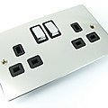
- If a power socket is not working, check the consumer unit and reset if necessary.
- If it trips again unplug the appliance, reset the consumer unit again and try a different socket.
- If this also trips it is the appliance that is faulty, and you should contact a qualified electrician.
- If it is the wiring that is at fault; please contact New Build Aftercare West.

16.0 Meter Location
Your electrical meter can be found at the front/side elevation of the property (external).
The meter and meter cable are the supplier’s property and should NOT be tampered with in any way.
Your electricity supply can be turned off at the Consumer Unit which is situated in the storage cupboard underneath the stairs.

Safety Information
Always unplug any appliance before working on it.
Always ensure that your appliances are fitted with the correct fuse.
Always follow the manufacturer’s instruction on wiring appliances.
NEVER use an electrical appliance in the bathroom.
DO NOT attempt to repair, alter or extend electrical installations.

IF IN DOUBT CONTACT A QUALIFIED ELECTRICIAN.

Circuit Breakers
You are protected by a residual circuit breaker or RCD. These breakers are easy to re-set by flicking the switch back to the ON position on the consumer panel.
Circuit breakers are generally more sensitive than fuses and may well trip out even when a light bulb fails or you are using an appliance with an electrical fault or faulty plug
ELECTRICITY CAN KILL
DO NOT carry out any works on any electrical circuits unless you are a fully qualified electrician.

17.0 Using Your Energy Wisely

Did you Know
Turn your thermostat down by 1°C and you could save 10% off your bill!!

Included within the appendix to this guide is ‘The Buyers Guide to EU Energy Labelling’ for when you purchase a new electrical appliance. The label will be found on most appliances and provides the information you need to compare the energy efficiency, water consumption and noise levels of the appliance you are buying, including light fittings and bulbs.
IN order to promote energy efficiency, we have included below a number of practical considerations:

When Cooking…

- Use a kettle to boil water for cooking. It is quicker and uses less energy than a pan.
- Take shelves you don’t use out of the oven.
- Only fill kettles with the water that you need.
- Cut food into smaller sections before cooking; it may cook more quickly.
- Use just enough water to cover vegetables and put the lid on. Simmer instead of boiling: less steam means less need to ventilate the room, cutting your heating costs.
- Don’t keep opening the oven while cooking.
- Use the right size pan for the cooker ring.
- Make toast in a toaster, not under the grill.
- Use pans that can divide into sections; you can cook several items at once.
- Use a microwave instead of the oven as much as possible – not just for re-heating and defrosting but for fresh food too.
- It is more energy efficient to use all the oven space available. Cook big batches of food at once then freeze food you do not need that day. The meals are then quick, easy and economical to reheat, especially if people in your household eat at different times.
When doing the Laundry…
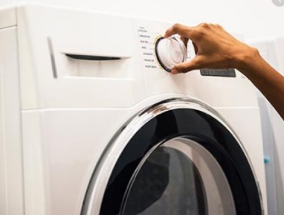
- Always try to put a full load of washing into your washing machine or tumble dryer.
- If you use a tumble dryer, spin the clothes they will then tumble dry more quickly.
- Wash clothes at 30˚C. You can wash four loads at 30˚C for the same price as one wash on the highest temperature.
- Do not turn up the tumble dryer thermostat or dry your clothes for too long – you can avoid having to iron everything.
- Use economy programmes on your washing machine for small loads or items which are not very dirty.
- Plan your ironing so you don’t have to keep changing the temperature setting on your iron. Iron the clothes that need a cooler iron first, and finish with clothes that need the hottest setting.
- Front loading washing machines are usually more efficient.
- Dry your washing outside on a fine day.

18.0 Be Water Wise-Tips to Reduce the Use of Water

In the Kitchen
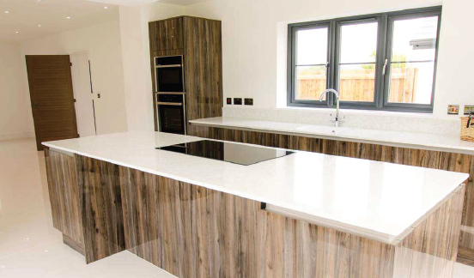
- Use a washing up bowl when washing up.
- Fix leaking taps.
- Rinse vegetables in a bowl.
- Try to avoid rinsing dishes in the sink before loading them into your dishwasher.
- Store drinking water in the refrigerator rather than running the tap every time you want a cool glass of water.
- Wait until you have a full load before doing your washing, or use the half load button on your washing machine. The same goes for the dishwasher.
- Hand wash small amounts of clothes in a bowl.
- Fill the kettle with only as much water as you need - you will save electricity as well as water.
- If you need to purchase a new water using appliance, check how water efficient it is before you buy it.
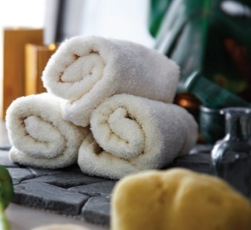
In the bathroom
- Take a shower not a bath.
- Put the plug in the sink when you wash.
- Don’t leave the tap running whilst cleaning your teeth.
- Always make sure you turn the taps off fully.
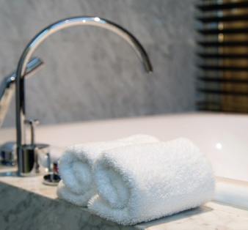
- Avoid flushing the toilet unnecessarily - dispose of tissues, insects and other such waste in the bin rather than the toilet.
- Fix leaking taps.
- Fit a flow regulator to your shower.
- When installing or replacing toilets, opt for dual flush and low flush cisterns.

Tips for around the home

- Ventilate your home properly and regularly.
- Avoid drying clothes indoors.
- Close the door when cooking or bathing to restrict moisture.
- Wipe down kitchen and bathroom surfaces after use to remove surplus water.

19.0 Lawn Maintenance
As with any new build home, your garden may take a number of seasons to establish, particularly if you live in an area which has a more clay-like soil. Although we provide the appropriate amount of topsoil to your garden before we lay turf, this alone will not see your turf stay green and healthy.

Many issues which arise with lawns can be avoided through consistent homeowner maintenance, so we strongly recommend following the below advice. Useful information is also provided by the Royal Horticultural Society via their website at: www.rhs.org.uk/advice.

Dealing with leatherjackets
Leatherjackets are a natural occurrence but unfortunately their larval stages can interrupt crops and lawns. They are soil-dwelling larves or flies known as crane flies or daddy-longlegs and emerge from the soil during late summer.

Leatherjackets can be a problem as they feed on the roots of grass, causing plants to die and resulting in large patches of bare grass.

The easiest way to spot leatherjackets in your garden is by coming across the long grey/brown grubs when digging. Signs of leatherjackets can also include birds pecking at your grass or patches of grass coming away without any roots.

To deal with them, try applying a nematode treatment to affected areas after rain or the use of a sprinkler. Nematodes are natural and some will be in your lawn already, but applying more ensures they kill the grubs.

As a preventive measure, apply nematodes in September to early October. You may need to water the lawn before and after application to ensure the soil is sufficiently moist for nematode activity and survival.

Ongoing lawn maintenance

Water – Water newly-created lawns thoroughly, provided there are no hosepipe restrictions in force. Water during early morning, evening or even night-time, rather than the hottest part of the day, to reduce water wastage from evaporation.
Watering once every 7-10 days is normally sufficient. It is important not to apply too much water. This encourages shallow rooting of the grass and promotes moss and turf diseases. Excessive watering makes the lawn less drought-tolerant in case of hosepipe bans or holidays when watering is discontinued.
For established lawns, water it once the soil becomes dry but before the grass colour changes. If the ground is very hard, aerate it by spiking with a garden fork before watering to aid water penetration.

Mowing your lawn – Raise the height of the cut in dry weather to avoid weakening the grass, and let the clippings fall back onto the lawn rather than collecting them. They will act as mulch and slow down the evaporation of water from the soil surface. Make sure the clippings are small, or they will smother the grass and cause damage.

Weeding – Pull out any weeds as soon as you notice them as they can attract pests, diseases and infections.
Don’t disturb your soil – Be careful not to over-dig in hot weather – disturbing your soil will only get rid of moisture.

Be aware of what your warranty will and will not cover – Please remember that it is your responsibility to maintain your garden, and that your warranty does not cover wear and tear, neglect and failure to do the appropriate maintenance. We also cannot cover storms and severe weather conditions, flooding and changes in the water-table level and these should be insured by the homeowner personally.

No Dig Zone

Due to NHBC best practice a hi-vis orange membrane has been installed in your garden. This is used to separate old soil, from new soil imported, where there is a higher concentration of pollutants, which could be due to the impact of past activities affecting the underlying soil and is common in the south Wales region.
The membrane is 600mm down under 450mm of subsoil and 150mm of topsoil. This means that you are unable to dig any further than 600mm. The depth means that it is unlikely you will come into contact with the membrane unless significant building works are being carried out.

20.0 Other Considerations
Roof
High winds, driving rain and snow may cause damage to the roof and guttering. After a heavy storm it is advisable to check for leaks in the roof space. Any damage resulting from severe weather is not covered by the warranty and should be referred to your insurance company.
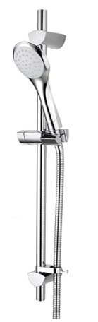
Do Not store materials in your loft space.
Shower
Your shower is a Bristan Capri Thermostatic Shower.
For settings and operation please refer to the user manual.
You can find a copy of the manual on My Pobl Home.
Lights

Internal - Your home has been fitted with low energy fittings. Please note the correct size if you are fitting lampshades.
External - You have external lights fitted at the front, and rear of your home. For settings and operations please refer to the user manual.
Doors & Window Inspections
All doors and windows should be checked for proper seals and broken glass. Once a year clean and lubricate all moving parts. Check weather stripping for damage and tightness each autumn. Check decorators’ filler at doors, windows and other openings and joints between dissimilar materials such as wood and masonry. Door closures, locksets and thresholds should be checked and adjusted as needed.
Cleaning and Care: -
- Use only warm, soapy water with a soft sponge. Never use abrasive, chemical or solvent cleaners. Keep drainage slots clear.
- Locking mechanisms should be kept clean and lightly lubricated.
- Hard tools must not be used to scape glass.

Flooring
Some floors are covered with vinyl sheet which has been stuck down. These floors may be cleaned with water and a mild detergent or a proprietary floor cleaner.
Please ensure that no hard-abrasive cleaners are used.
Walls and Ceilings
All walls to the dwelling are of masonry construction which has been plasterboard dry lined and skimmed. The ceilings have been constructed of plasterboard fixed joints with a plaster skim.
Fixings
Be careful when nailing or drilling into floors, walls or ceilings to avoid contact with any electrical cables or pipes, which may lie beneath the surface. We recommend that you invest in a cable/ pipe/stud detection device in order to carry out your own check prior to drilling.

NEVER ATTEMPT TO DRILL OR NAIL A FITTING DIRECTLY ABOVE OR BELOW OR HORIZONTALLY TO ANY SOCKET OUTLET OR SWITCH.
Plasterboard partitions need the correct type of fixings, not just nails. Please ensure you use the correct fixings. Only light weight objects such as wall mirrors and pictures should be hung on partition walls.
Sanitary ware
Baths, basins and sinks should be cleaned with recommended products to avoid damaging the surfaces.
DO NOT use scouring or gritty cleaners. Bleach should not be mixed with lavatory powders nor be allowed to stand in stainless steel sinks.
DO NOT flush unsuitable items such as disposable nappies down the toilet.

THIS WILL LEAD TO BLOCKED DRAINS AND CHARGES
WILL BE INCURRED FOR CLEARANCE.

Sustainable Drainage System (SuDs)
Attenuation Basin
The pond is a water storage area that will fill and lower to reflect the amount of surface water within the system before it is discharged slowly. After periods of heavy rain, the pond will fill before slowly returning to its normal water level.
It is important that care is taken when walking near these ponds with young children and pets.
Permeable Paving
Permeable paving is block paving that allows water to filter through the gaps to soak away.
At The Willows there are sections of permeable paving on roads and private driveways. Responsibility will be detailed in your conveyancing pack.
Your parking spaces have been designed as permeable paving; please note that the paving must not be removed or altered as they form part of the wider drainage strategy.

Safety on Site

If construction work is ongoing when you move into your new home, we will always ensure that you have safe access to your home both by foot and by car and make every effort to keep dust, mud and noise to a minimum, however, at times this may be unavoidable.

Temporary fencing will be used to separate the finished homes from the live construction site. Please do not enter, or allow children, visitors or pets to enter the construction area. The temporary fencing will move as more of the homes are completed, so conditions near your home may change - this includes road conditions and traffic management systems. Always take note of signage for pedestrians and vehicles – these will inform you of changes and keep you safe. Please only park your vehicles in your designated parking spaces to keep roads free of potential obstructions.

Please be aware of construction traffic and take care when walking, cycling or driving around the site and to and from your new home. Large vehicles and machines will be moving around the site during working hours, therefore if you have children or have children visiting, you may decide to supervise outside play until construction work has completed.

Roads and footpaths may not be fully finished with the final layer of tarmac. This is normally applied when all homes on the development are finished – therefore surfaces may be uneven so please look out for trip hazards and be mindful of any raised ironwork in the roads when driving through the site.

Permanent street lighting may not be commissioned when you move in, this may mean that some areas aren’t well lit and extra care may need to be taken around these parts.

If the development you are living on has public open spaces, it is often the case that these areas are completed as construction work on the development is coming to an end, allowing the safe enjoyment of these spaces for the community once the majority of the construction work is complete.

Section 3: Local Amenities

21.0 Recycling Arrangements

For your collection day please visit your local housing website:
www.swansea.gov.uk/recycling or phone 01792 635 600


Bulky Items Collection:
Household waste that are too big for your black bags such as beds, carpets, fridges, freezers and wardrobes can be collected for a fee.
Items are recycled/reused where possible. Your local authority operate a fair use policy and they will only pick up a limited number of items per collection.
All collections must be booked and paid for in advance. This can be done online or by telephoning 01792 635600. There is a £23 fee for 1-3 items and £46 for 4-6 items.
Please note that items must be placed out on the kerbside for collection on the agreed date. The collection team is unable to enter the property.
Collections are usually made on the same day as your recycling and rubbish collections. Once you have made a booking an email will be sent to you within 3 working days to confirm the collection date.

22.0 Hospitals, Schools, and Other Services
General Hospital  Singleton Hospital  Sketty Lane,  Sketty,  Swansea.  SA2 8QA  Tel: 01792 205 666 | Dentist  Killay Dental Health Centre Ltd  11 Cygnet Close,  Killay,  Swansea.  SA2 7BD  Tel: 01792 202 078
Doctors  West Cross Medical Centre  82 West Cross Lane,  West Cross,  Swansea  SA3 5NN  Tel: 01792 404 157 | Chemist  Lloyds Pharmacy  The Precinct,  Swansea.  SA2 7BA  Tel: 01792 202 471
Local Schools & Nursery  Maes Enfants Ltd  742 Mumbles Road,  Mumbles,  Swansea  SA3 4EL  Tel: 01792 366 366  Sketty Primary School  Llwynnawr Road,  Swansea.  SA2 9HJ  Tel: 01792 206 655  Olchfa School  Gower Road,  Swansea,  SA2 7AB  Tel: 01792 534 300 | Post Office  Parkway Post Office  4-8 Parkway,  Sketty,  Swansea.  SA2 8JJ  Tel: 01792 204 938  Local Church  Parklands Church  Maes Y Gollen,  Sketty,  Swansea.  SA2 8HQ  Tel: 01792 204 767  Local Mosque  Swansea Mosque  159a St Helens Road,  Swansea.  SA14DG  Tel: 01792 654 532  Library  Sketty Library  Vivian Road,  Sketty,  Swansea.  SA2 0UN  Tel: 01792 202 024

23.0 Local Places of Interest

- Singleton Park
- Clyne Valley Country Park
- Gower Heritage Centre
- Langland Bay
- Oystermouth Castle
- The National Waterfront Museum



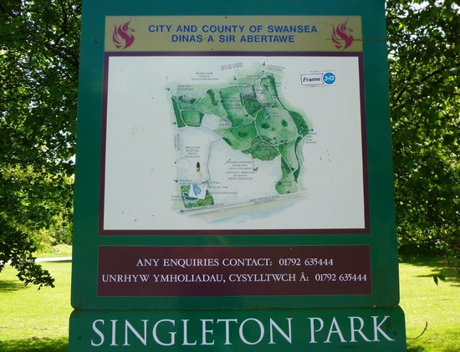




Section 4: Sustainable Stewardship

24.0 Home Composting
Identify when your refuse will be collected; i.e. green bags, pink bags and your food waste bin.
Did you Know
£12 Billion worth of food and drink that could have been used is thrown away every year which ends up in landfill.

An alternative to disposing of kitchen waste:
- Place your green waste into the compost bin. The more material is chopped up the quicker the compost will be produce.
- Spreading a little ‘already done’ compost will help the compost accelerate.
- Keep the compost pile moist: it should be damp to the touch, but not wet.
- Leave the pile for about a week; the compost will begin to bake and get warm. This is part of the natural rotting process.
- Add air to the pile by stirring or turning with a garden fork.

- The pile will begin to reduce in size. This is a good sign that the compost is being formed.
- If the compost turns slimy, add some shredded cardboard to provide fiber.
- If you mix the pile every week, it should be ready in about two months.
- If you don’t turn the mix it may take up to twelve months to form compost.
- Your compost should be dark brown colour with a crumbly texture.
- Mix the compost into the soil and watch your plants grow.
Compost Materials:
What can be put into compost:
- Vegetable and fruit peelings  - Hay and straw  - Grass cutting  - Leaves  - Ashes | - Sawdust  - Teabags  - Ground coffee  - Wood chips  - Weeds and other plants  - Shredded paper and cardboard

What not to compost:
- Large tree pruning
- Meat scraps and bones
- Cooking oil
- Cat and Dog waste
- Plastic coated mater

25.0 Sustainability—the Whole Life Approach
- Buy fresh produce in season, organic where possible and support local growers and farmers.
- Choose products with as little packaging as possible.
- Take your own bag or re-use plastic bags.

- Try environmentally friendly or green goods, even if they cost a little more.
- Source your materials responsibly when carrying out DIY works, e.g. FSC certified timber, low VOC
- (volatile organic compounds) products such as paint, cleaning products, carpets etc.
- Buy products from Fair Trade Companies that do not exploit third world communities.
- Recycle where possible and recycle your kitchen waste.
- Take a shower instead of a bath.
- Give old magazines to doctors and dentists for their waiting rooms.
- Switch off lights and electrical appliances when not in use.
- Insulate your home and adjust radiator thermostats needed in each room.
- Use low light energy efficient appliances.
- Grow your own food in the garden or allotment.
- Choose alternatives to peat.
- Cut down the use of pesticides.
- Introduce an eco-pile or bird feeder to encourage wildlife.
- Think of others—keep the noise down.

Section 5: Useful Contacts
We hope you enjoy your new home and wish you and your family every happiness from all the staff at Morganstone.

Morganstone Ltd
Unit 3 Llys Aur
Llanelli Gate, Dafen
Llanelli
Carmarthenshire
SA14 8LQ
01554 779 126
mai l @morgan ston e.co.uk

Pobl
Pobl House
Phoenix Way Enterprise Park
Swansea
SA7 9EQ
0330 175 9726
info@poblgroup.co.uk

Energy Saving Trust Wales
1 Caspian Point
Caspian Way
Cardiff Bay Cardiff
CF10 4DQ
02920 468341
www .en er gysavi ngt ru st .org.u k



Appendix One
User Guides

Appendix Two

Buyers Guide to
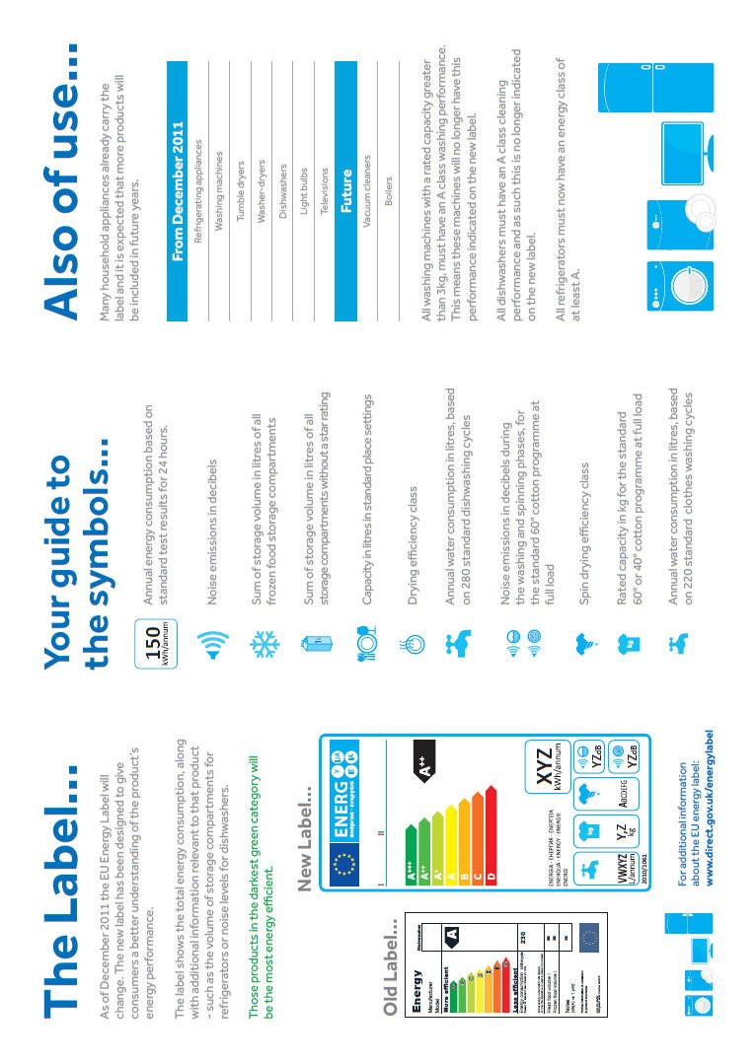
EU Energy Labelling

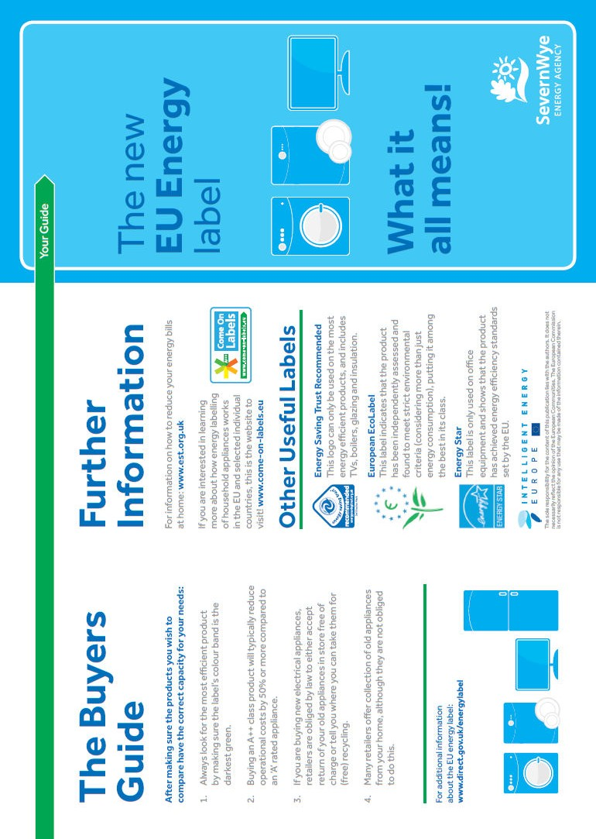

Certificates
Appendix Three

